Integration of DocuSign with Power Pages

Version | Author | Date | Purpose (Reusable) | Project/POC
1.0 | MANOJ KUMAR DHOTE | 24 APRIL 2025 | Reusable: Detailed Reference document to setup the Docusign Integration with Power pages | This document is based on the implementation is done in London business school POC.

Table of Contents
1. DocuSign Login & Template Configuration 4
1.1 Create a DocuSign Account 4
1.2 Create a Template 4
1.3 Add Documents to template and Add Recipients (just Role Name and note it down) 5
1.4 Map Fields (Signature, Initials etc) into the uploaded document 6
1.5 Grab Template Details to use further to configure in power pages 7
2 Power Pages Design 7
2.1 Create a Power Pages Site 7
2.2 Create / Select a Dataverse Table 8
2.3 Create Forms for the table (multistage form is required) 9
2.4 Create a Mutistage Page and add form on to the page 10
2.5 Sync the page and preview the page. 12
3 Power Pages Setup-Install Docusign and Configure 13
3.1 Under Power Pages Setup > External Apps - Install DocuSign app 13
3.2 Post Installation, Configure DocuSign App 14
3.3 Navigate to Power Automate and resolve connection references for flows: 14
3.4 In DocuSign Envelope completed trigger flow, select the Account provisioned for DocuSign 15
3.5 Turn on both the flows 16
3.6 In 'Enable Integration section' - mark connection as resolved 16
3.7 Under Integrations section 'Enable' the Docusign application 16
3.8 Click on 'Add Template' 17
3.9 Populate the following fields grabbed from DocuSign and Save. 18
4 Add the cloud flow to the Power pages site( Most important flow which will run and get the documents from docusign) 19
4.1 Under Setup section in Design Studio, Navigate to Integrations > Cloud Flows 19
4.2 Select the 'DocuSign Envelope Create and Sign' flow and add to site 19
4.3 Flow “Docusign envelop create and sign”added to the power pages site 20
5 Add the Docusign Grid( PCF control ) to power page to show the documents to Sign 22
5.1 Navigate to Design Studio and edit the Form where you want to integrate the docusign grid (Step Settings) 22
5.2 For one of the steps in Form > Steps Settings > Integrations > Select DocuSign template 22
5.3 Docusign Grid added to form 24
5.4 Sync the Power Pages Site 24
6 Test the complete integration 25
6.1 open the portal page and click on the View and sign button. 25
6.2 Login to the docusign site and verify the status of signed doc 27

How to integrate DocuSign with Power Pages ?
DocuSign is a tool used to manage Electronic Signature. Microsoft Power Pages has a tight integration with DocuSign to allow portal users to extend and utilize the DocuSign functionality seamlessly without leaving the Power Pages user interface.
Steps to Integrate DocuSign with Power Pages using Power Automate are as follows:

DocuSign Login & Template Configuration

Create a DocuSign Account
- Create the Docusign account by getting licenses
- Create the 30 days trail
Using following link- https://trial.docusign.com/ you can create the trail account.

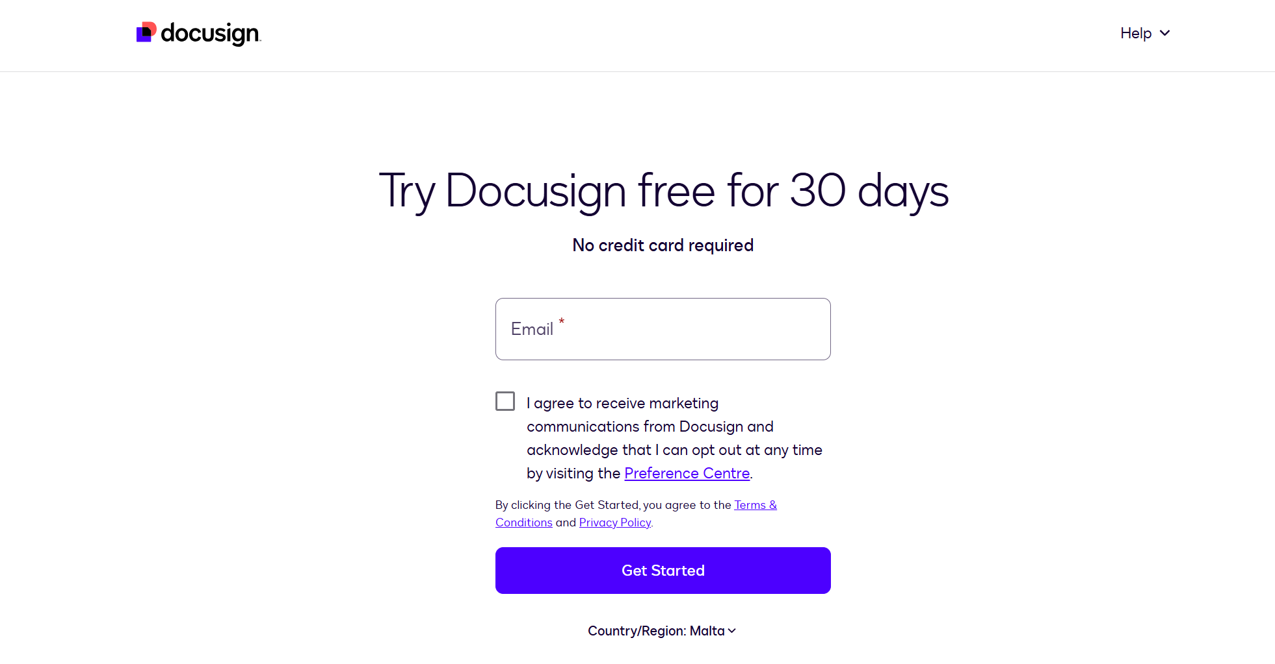

Create a Template
- Login to the Docusign – https://account.docusign.com/


- Select the Template from Main menu and click on create template button.
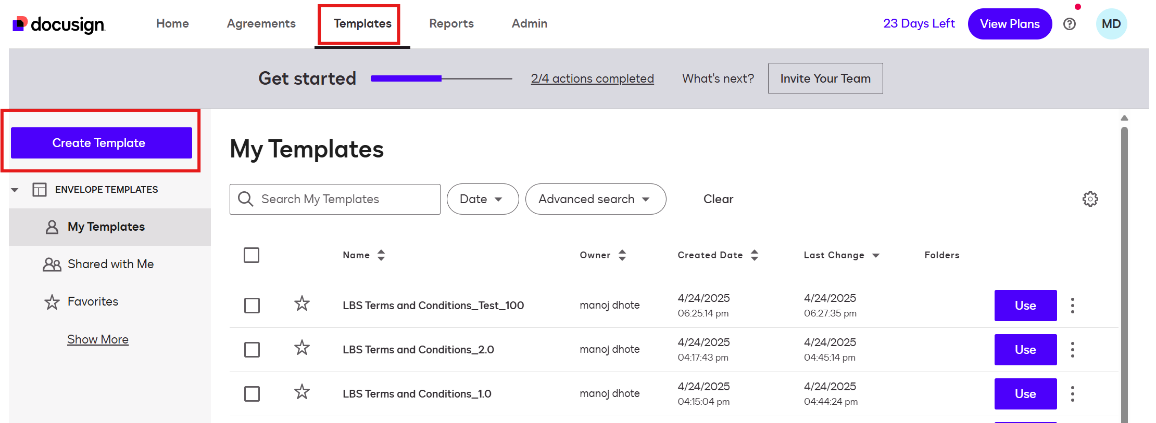

Add Documents to template and Add Recipients (just Role Name and note it down)
- Enter the template name, description, attach template doc, enter Role (anything is fine).

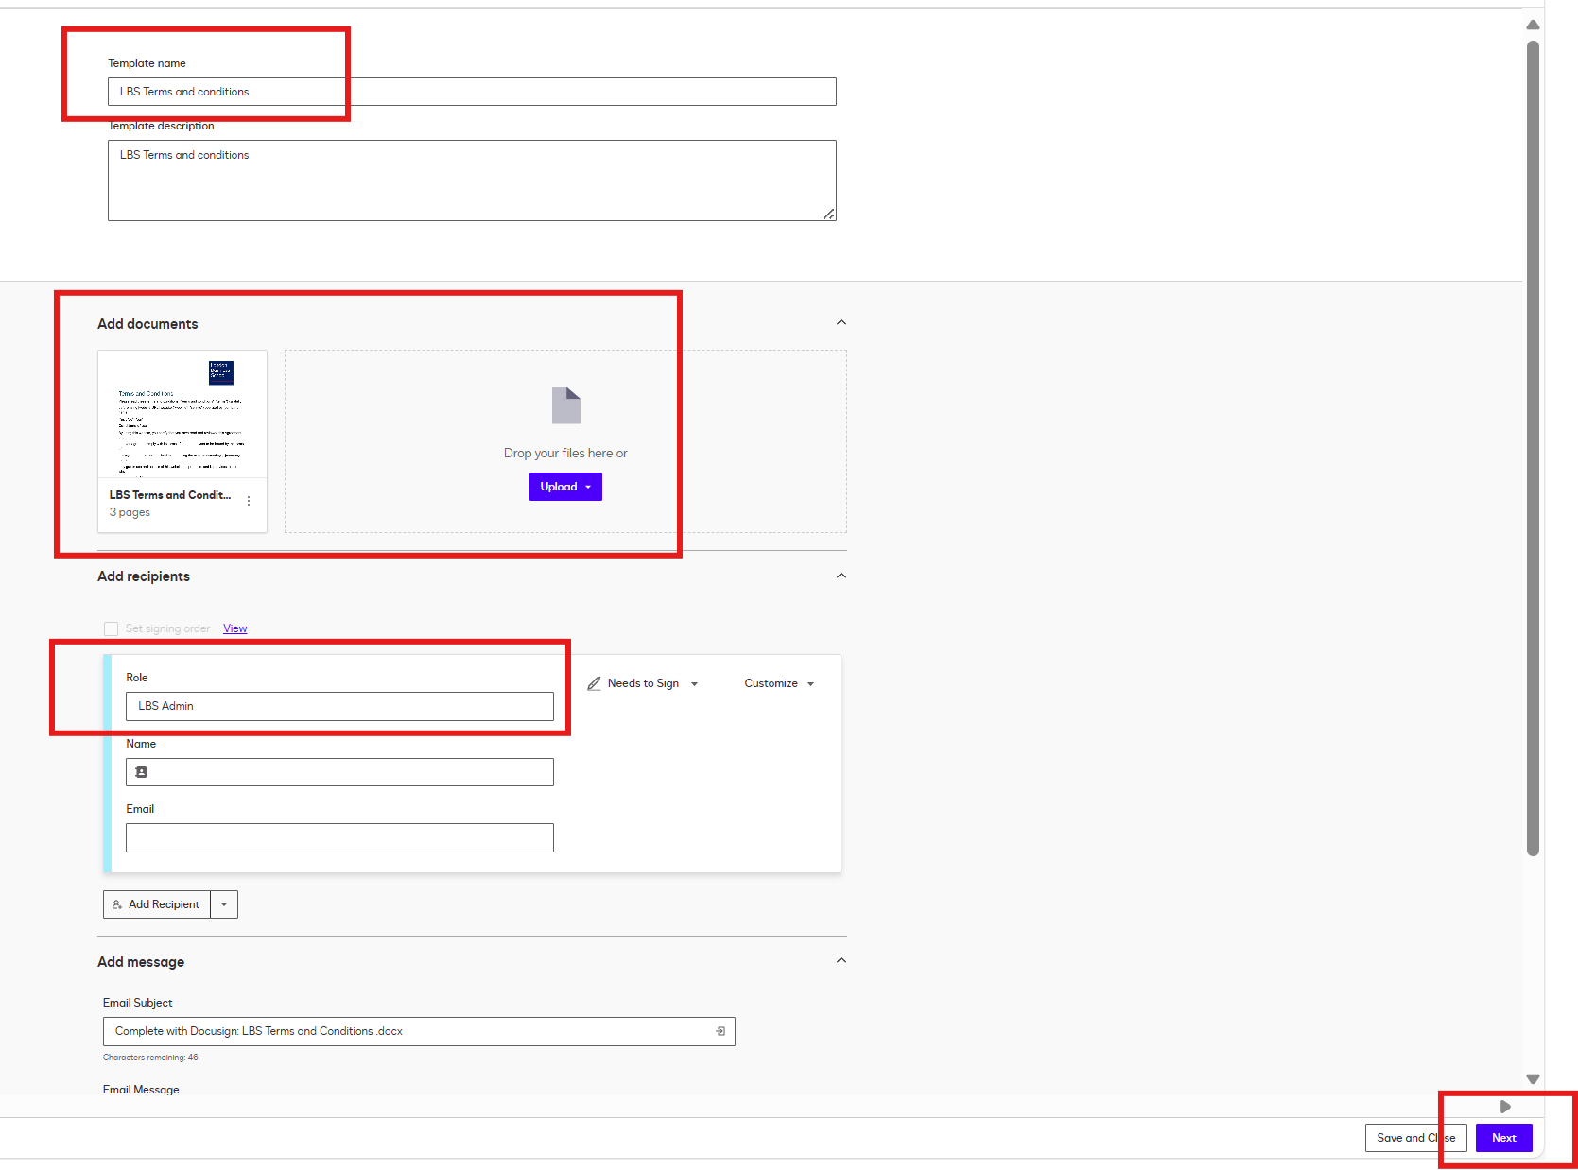

Map Fields (Signature, Initials etc) into the uploaded document
- Click on next button and enter your signature and other filed as per your requirements and click on save and close.
- 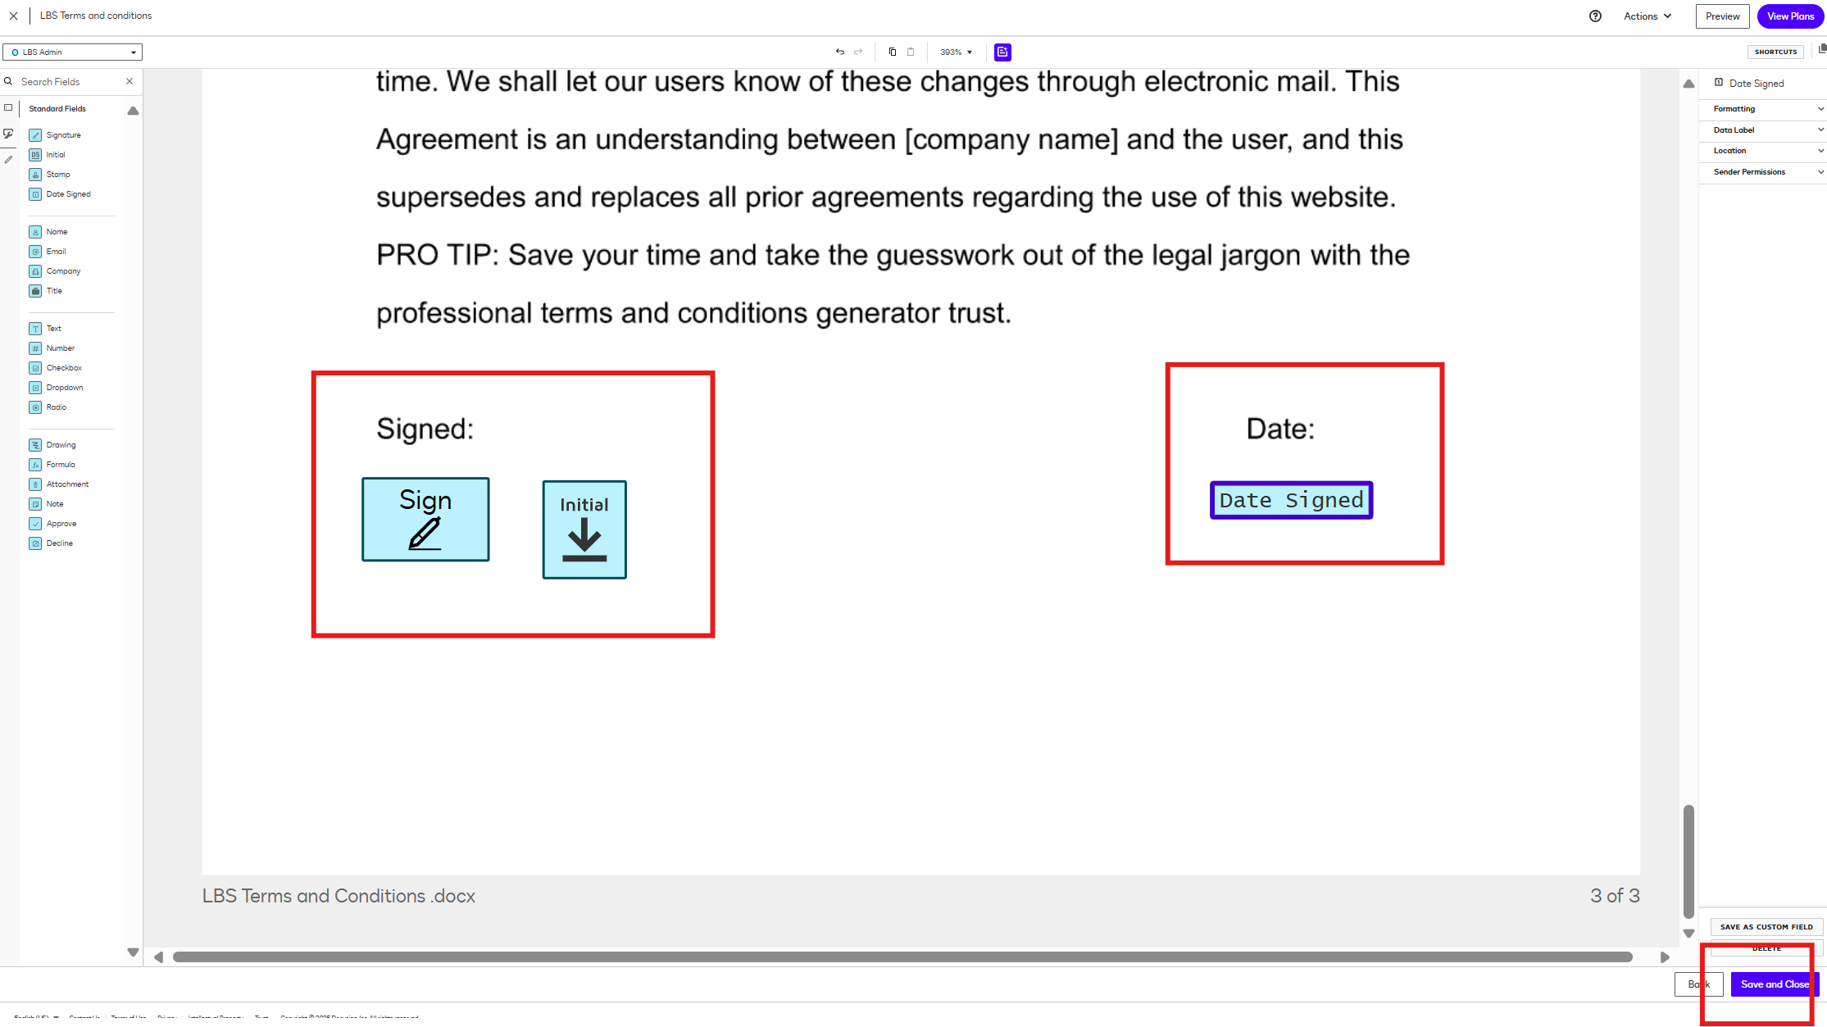

Grab Template Details to use further to configure in power pages
- Template ID
- Template Name
- Role Name
- Table
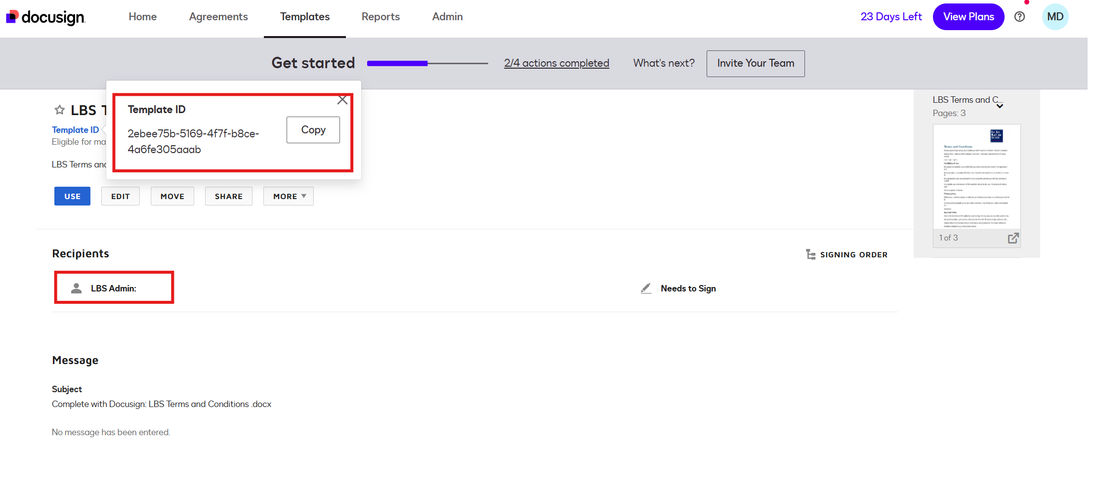

Power Pages Design

Create a Power Pages Site
- Go to :https://make.powerpages.microsoft.com/
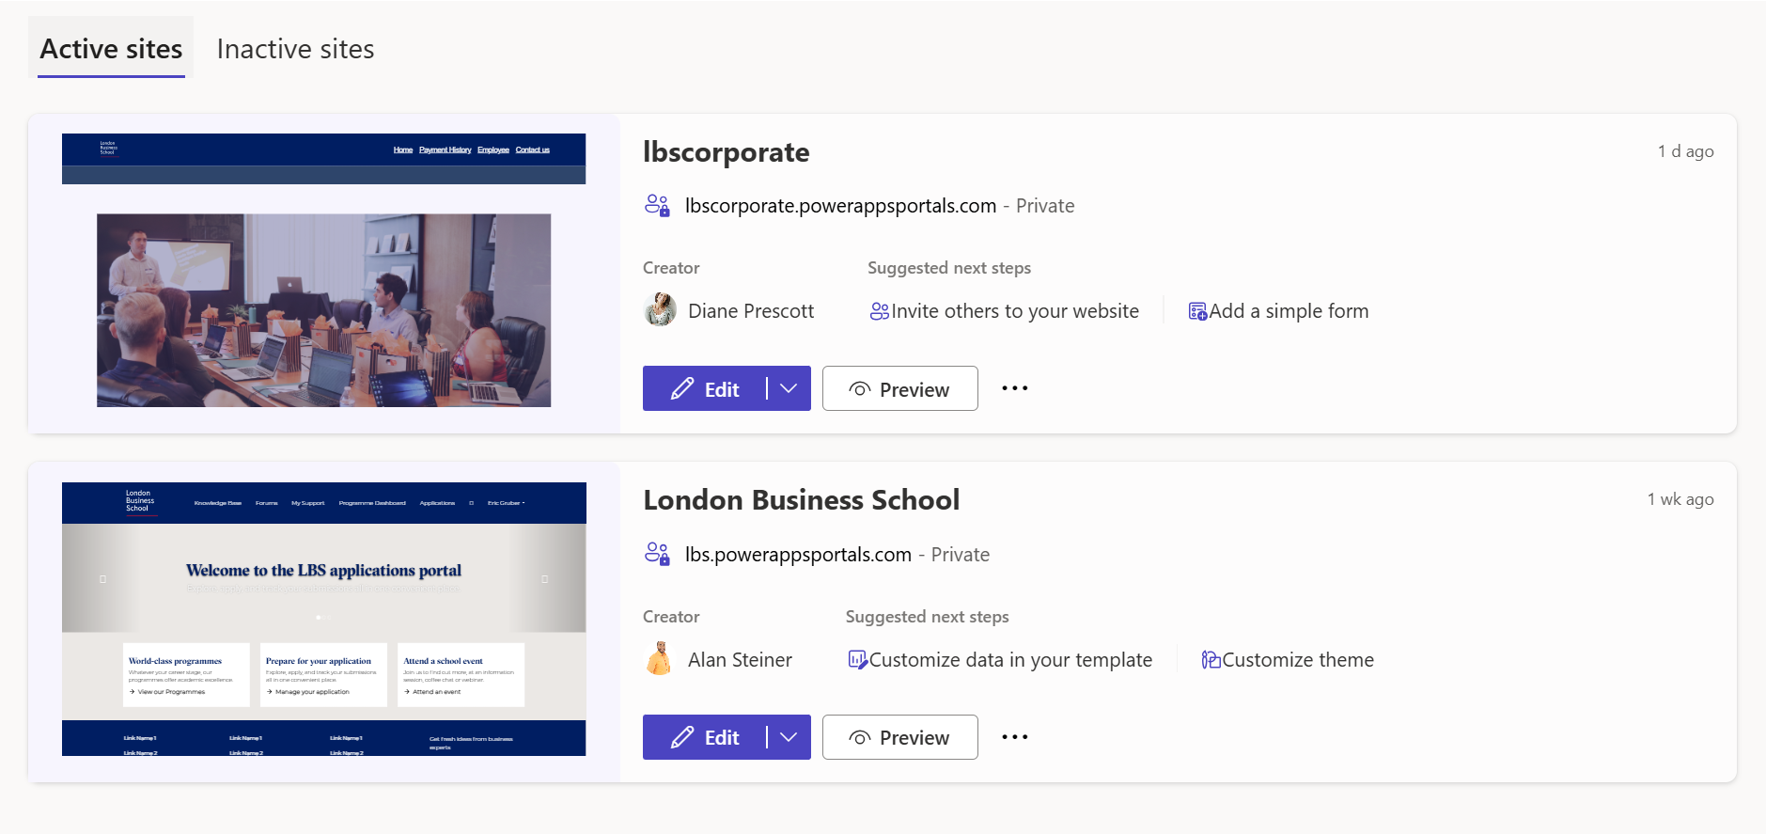

Create / Select a Dataverse Table
- While creating the table make sure to select the option from advance settings as Creating the new activity check box should be selected, its required to make the docusign integration to work. This option is available when table is created, once table is created this option will not able to edit. Refer the below screenshot for reference.
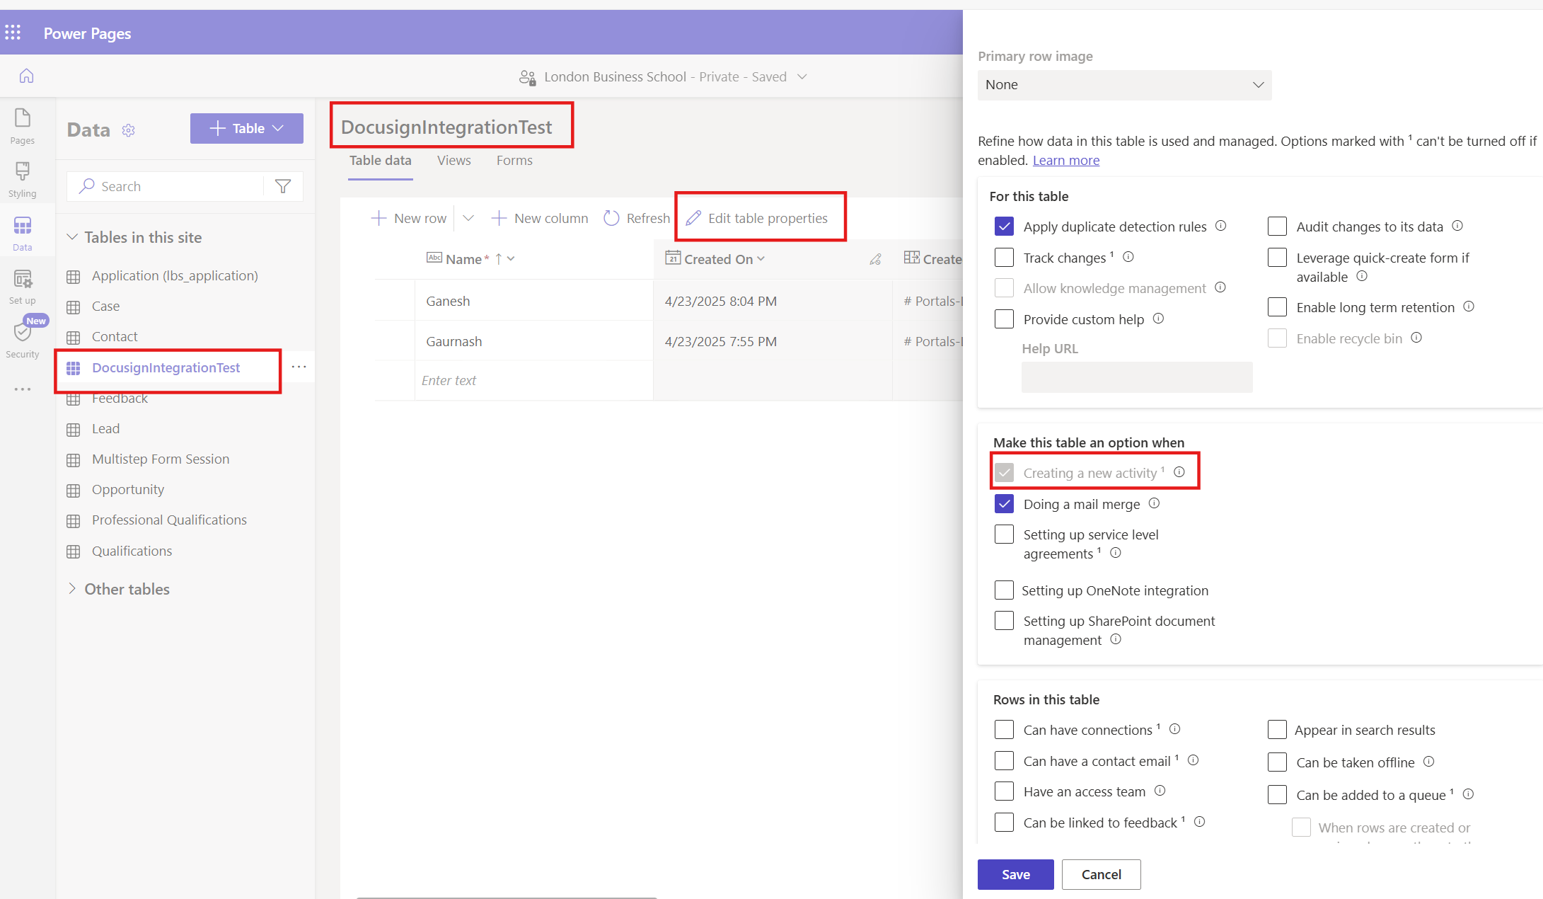
- Open the site – Select the Data tab from left Menu and create the table and required field as per your requirements.
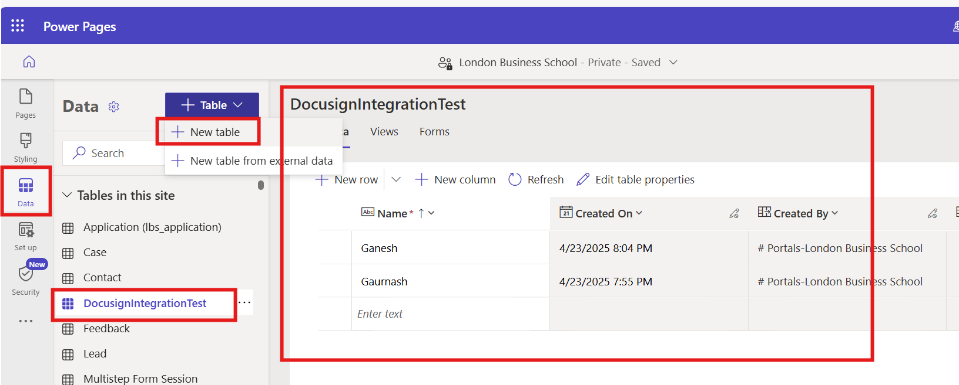

Create Forms for the table (multistage form is required)
- Note: Docusign in powerpages doesn’t have option to integrate with singlepage form. It only works with Multistage forms only.
- Created 2 forms for mutlistage as per my requirements where in signoff form will have the docusign integration.
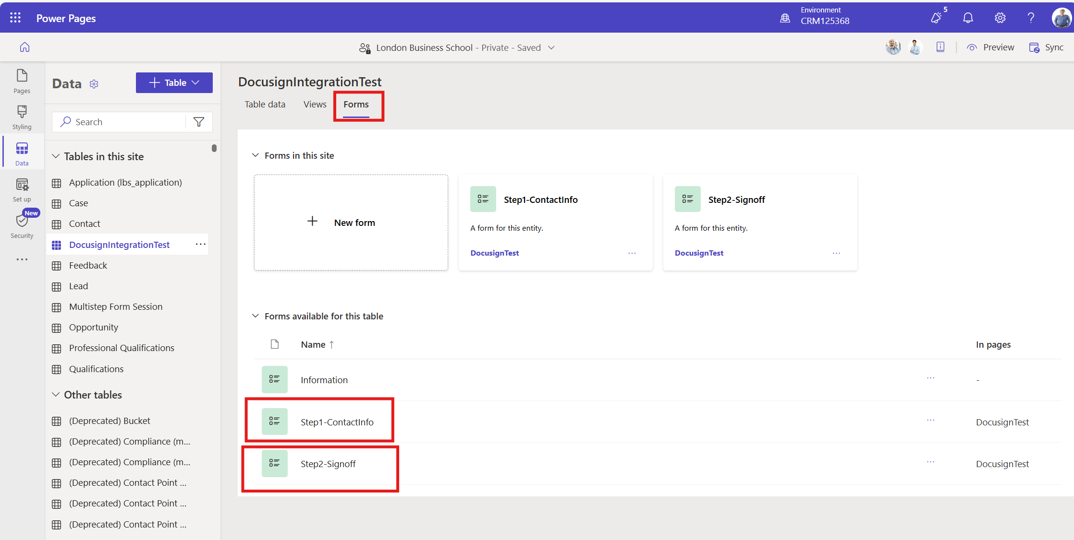
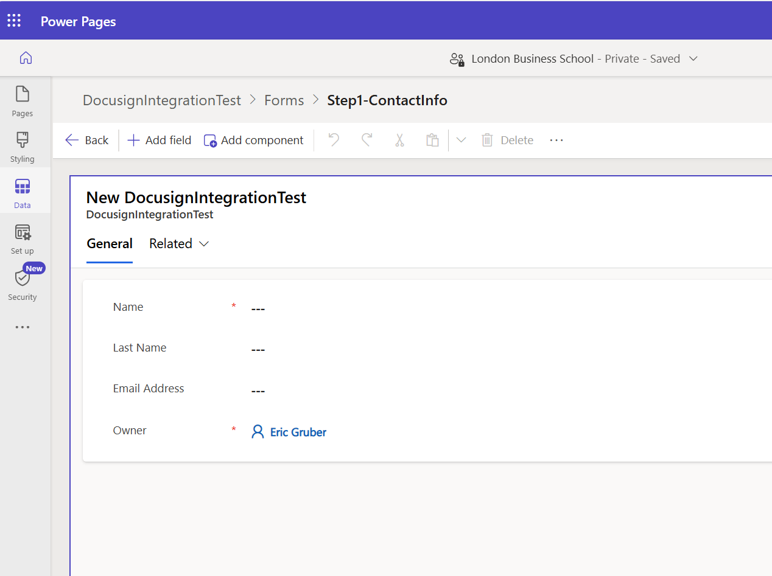

Create a Mutistage Page and add form on to the page
- Create the Mutistage page and add both the forms to the page.
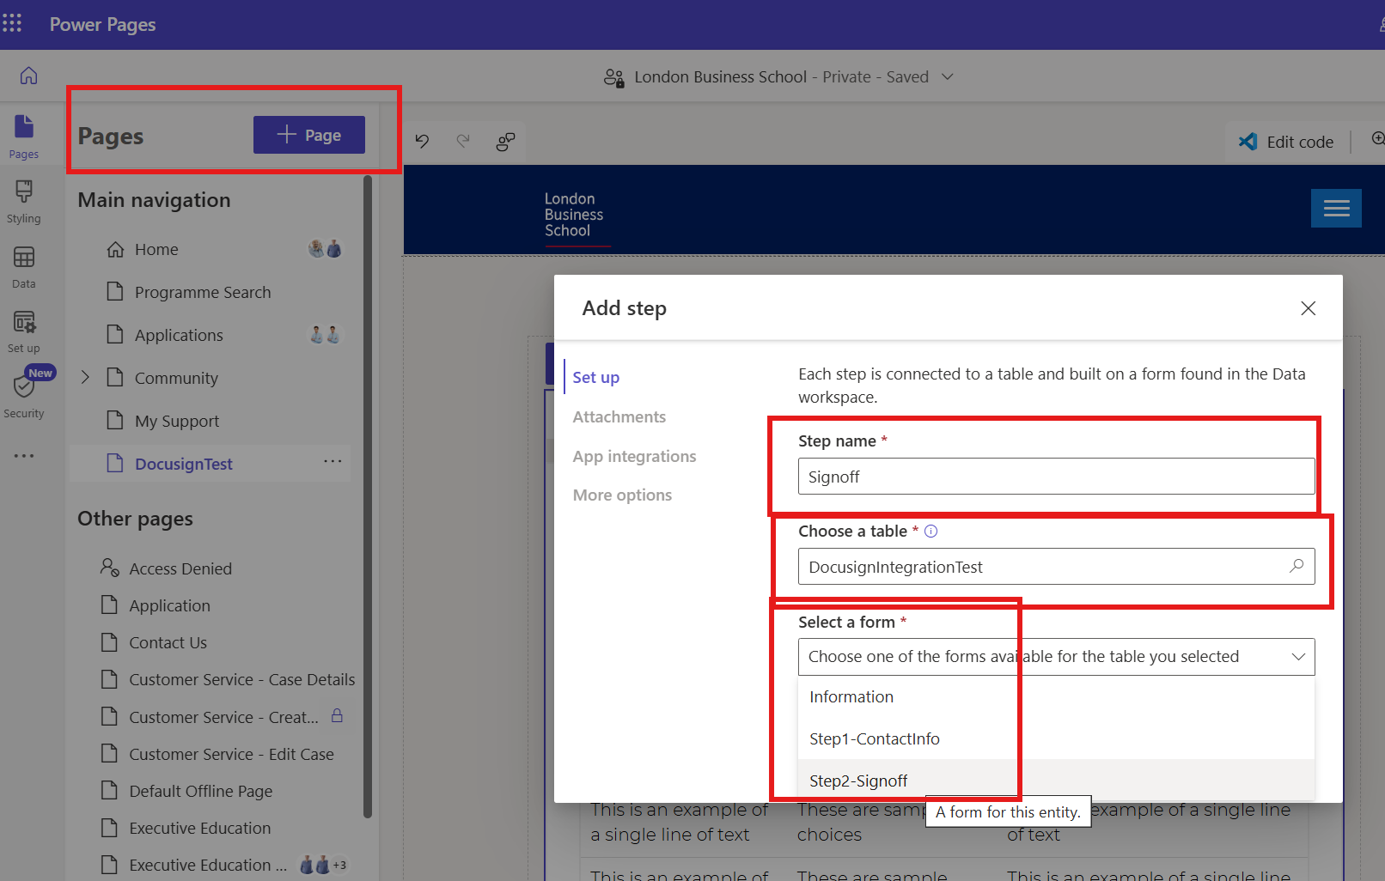
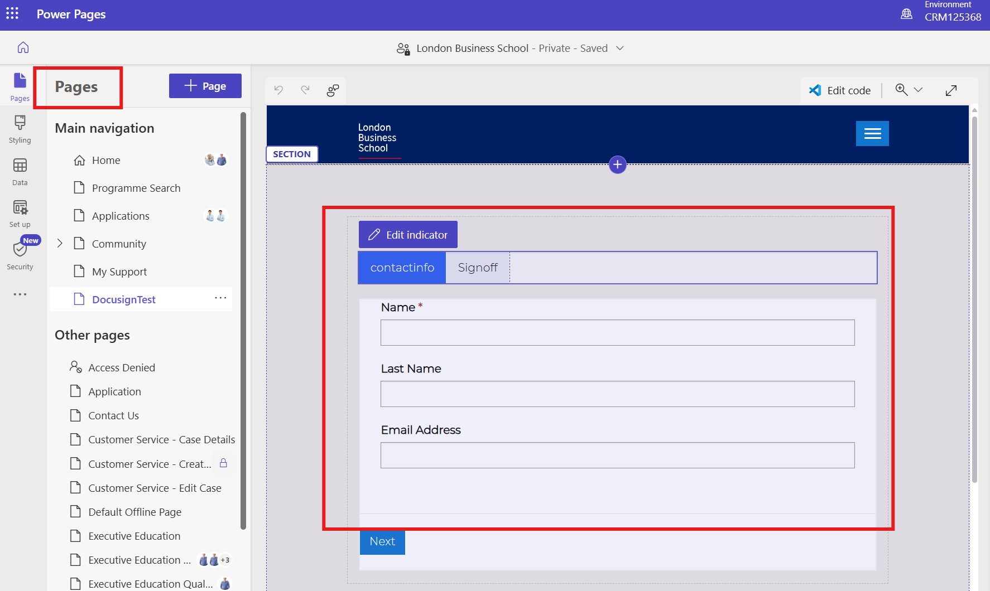

- Make Sure the role/permissions should be set for Table/page as Authenticated Users only as Docusign works with Authenticated Users only. Refer the below screenshot to set the Role and permissions.
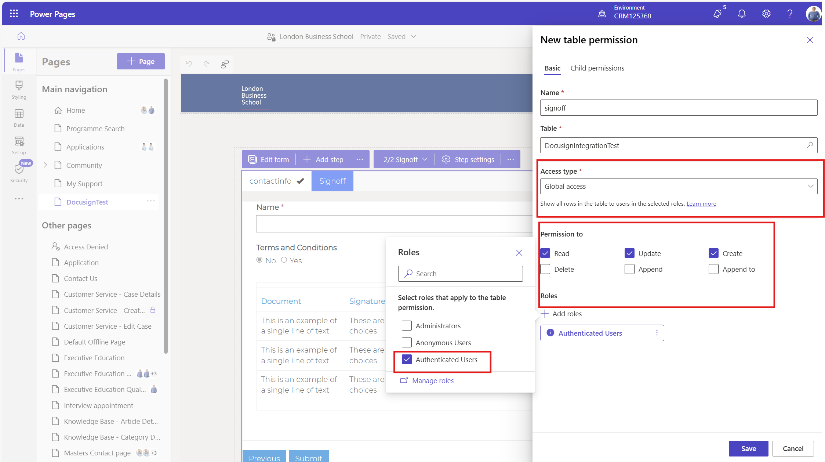
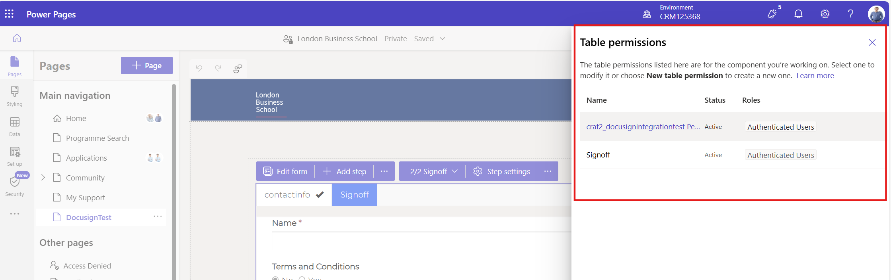

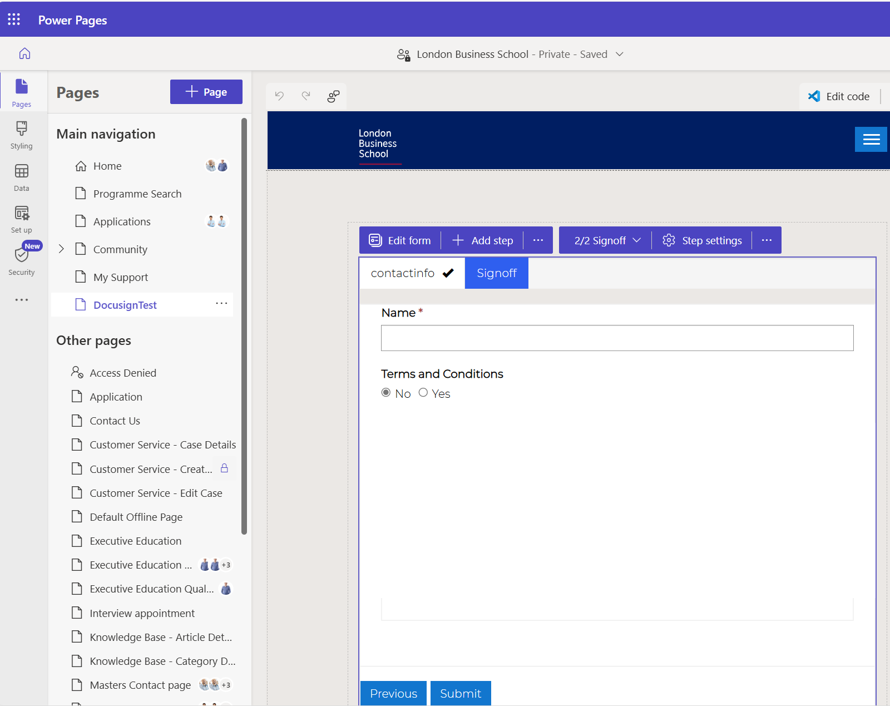

Sync the page and preview the page.
- Power pages are ready for the Docusign integration, follow the instructions below as mentioned in step 3.
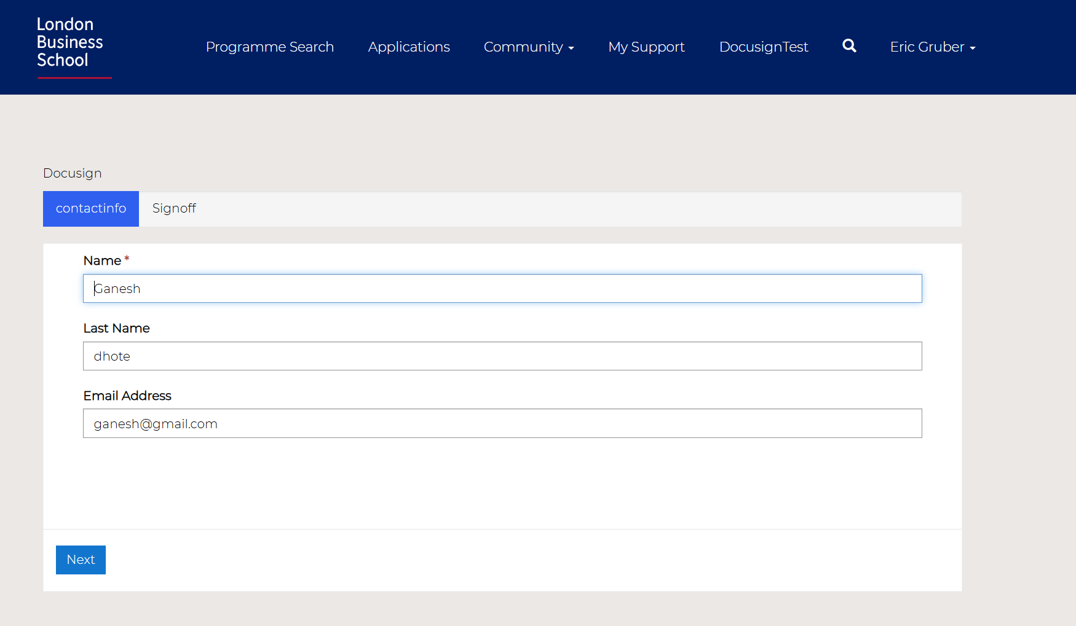

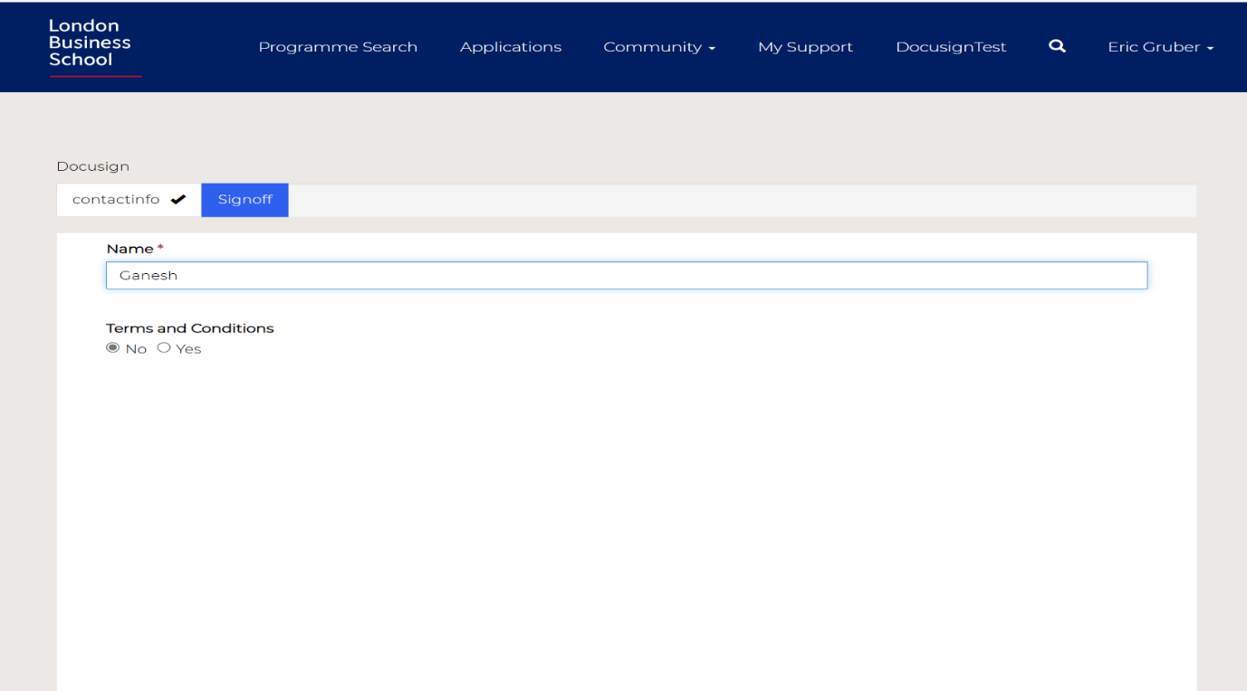

Power Pages Setup-Install Docusign and Configure

Under Power Pages Setup > External Apps - Install DocuSign app
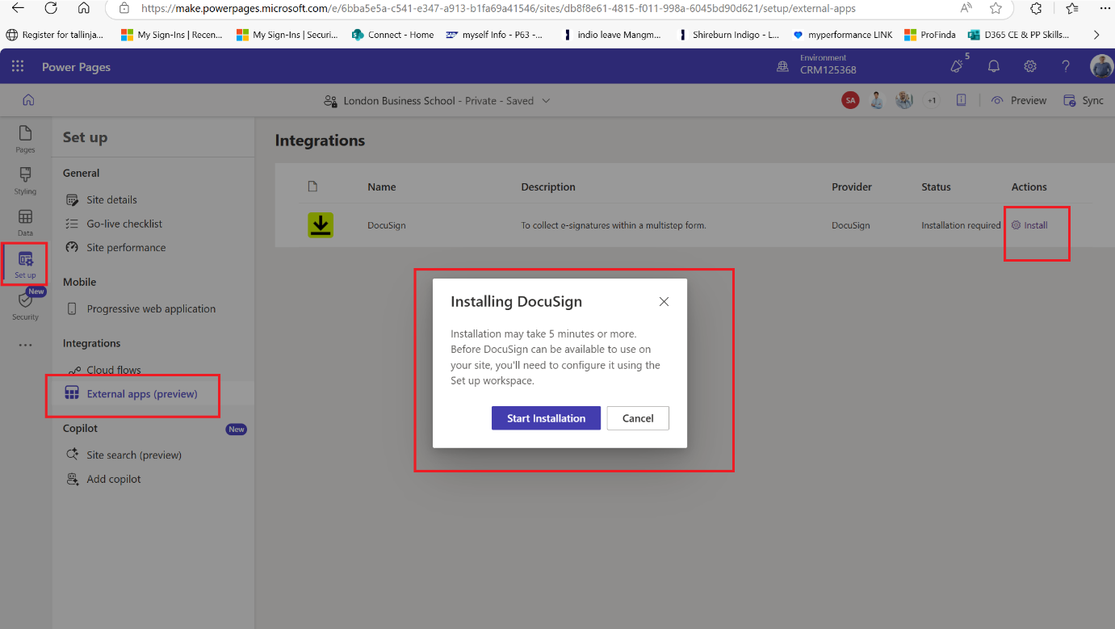

Post Installation, Configure DocuSign App
- Setup – External apps – and click on Configuration as highlighted in below image.
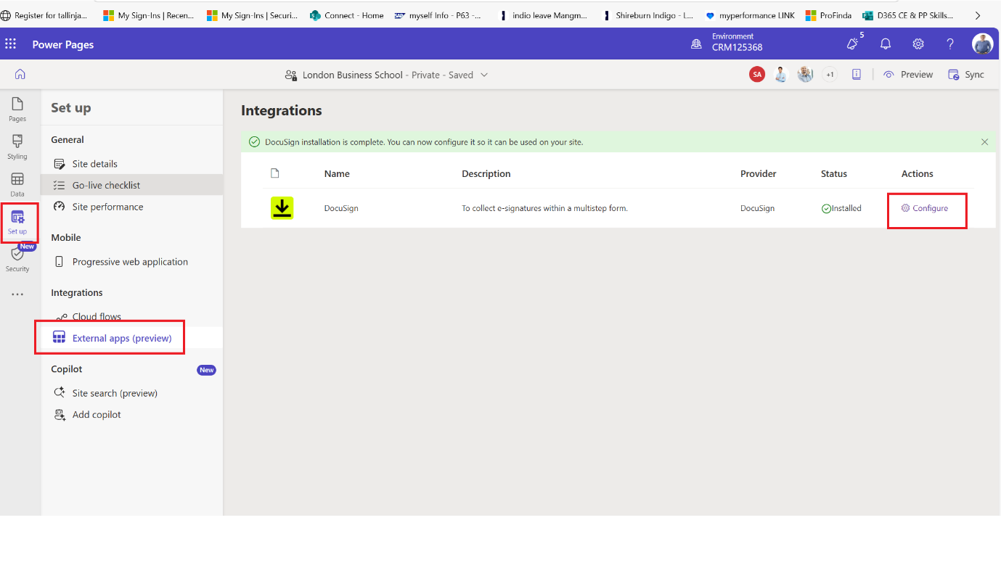

Navigate to Power Automate and resolve connection references for flows:
- DocuSign Envelope Create and Sign
- DocuSign Envelope completed Trigger

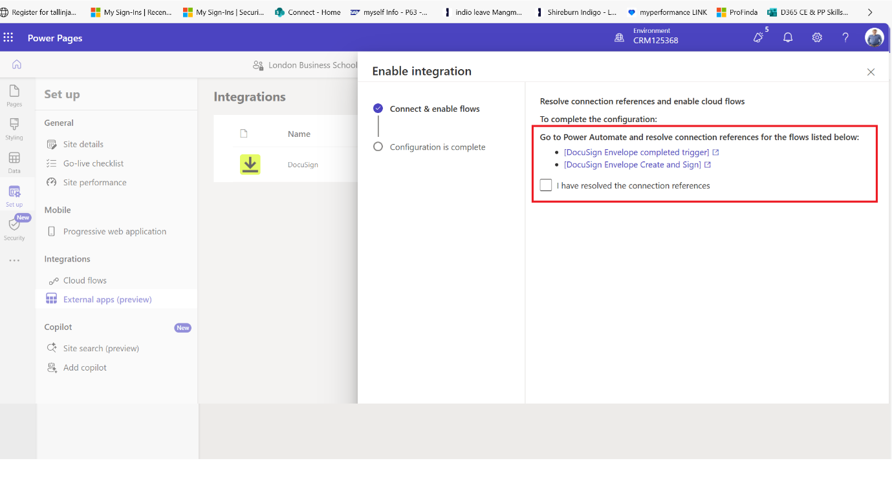
- Fix the connection reference for both the flows for data verse and Docusign.
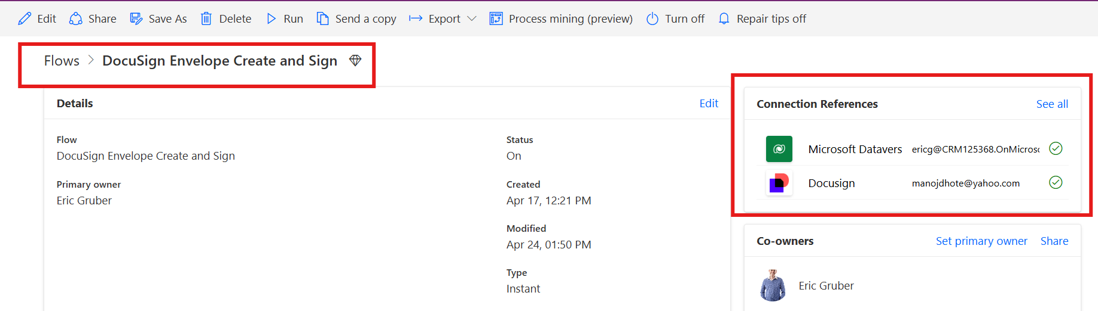

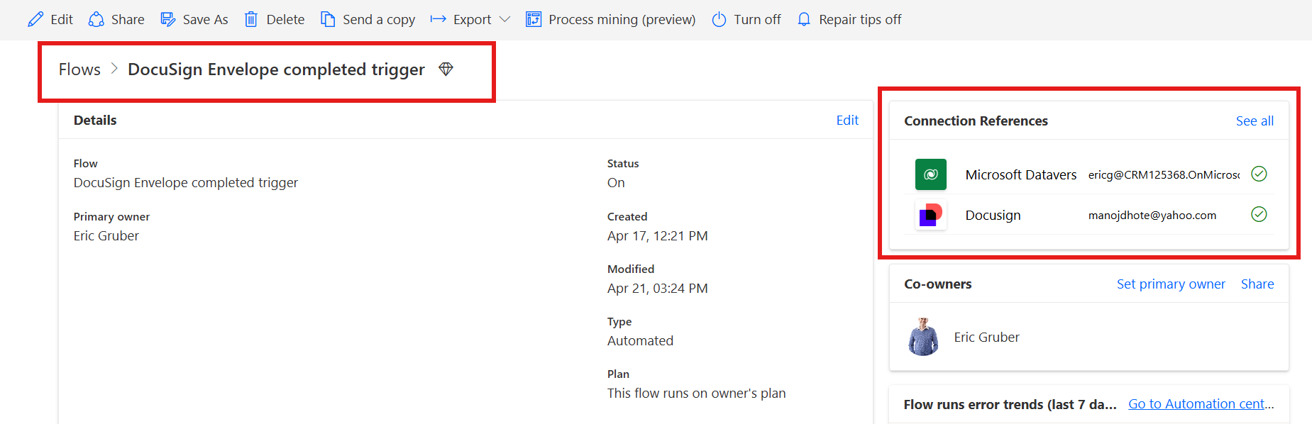

In DocuSign Envelope completed trigger flow, select the Account provisioned for DocuSign
- Edit flow and select the account to configure the docusign account, once connections are setup this will show you the account name so needs to select the account name as per the droop down list.
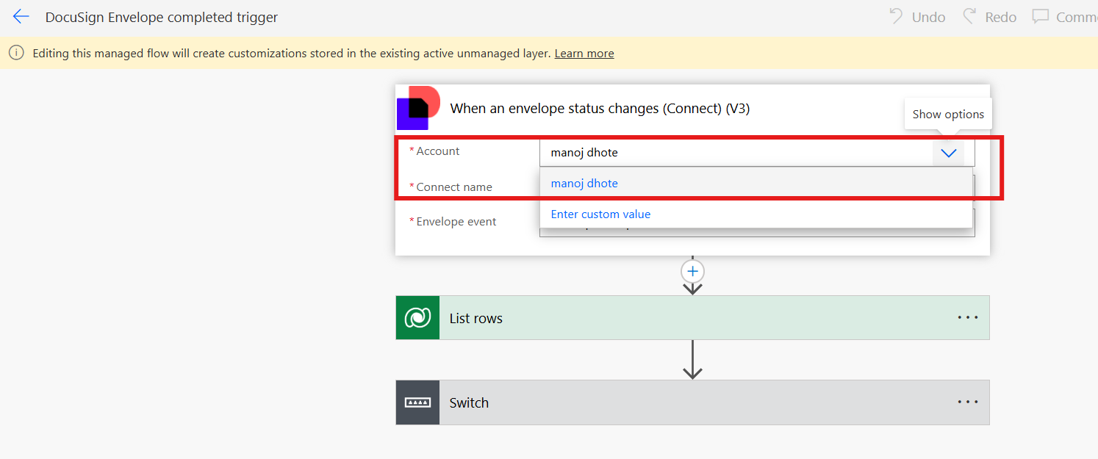

Turn on both the flows
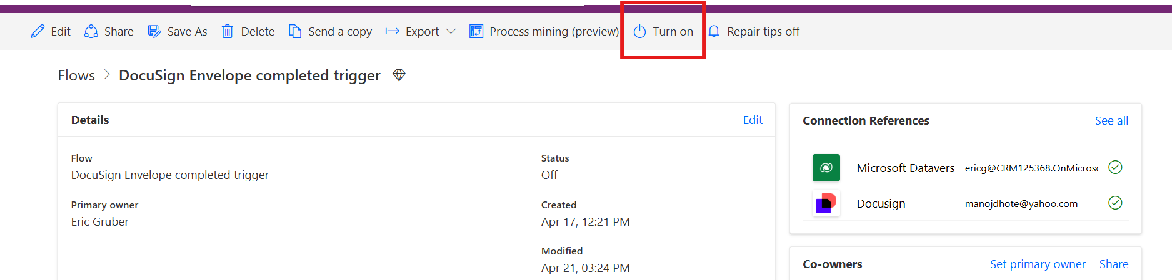

In 'Enable Integration section' - mark connection as resolved
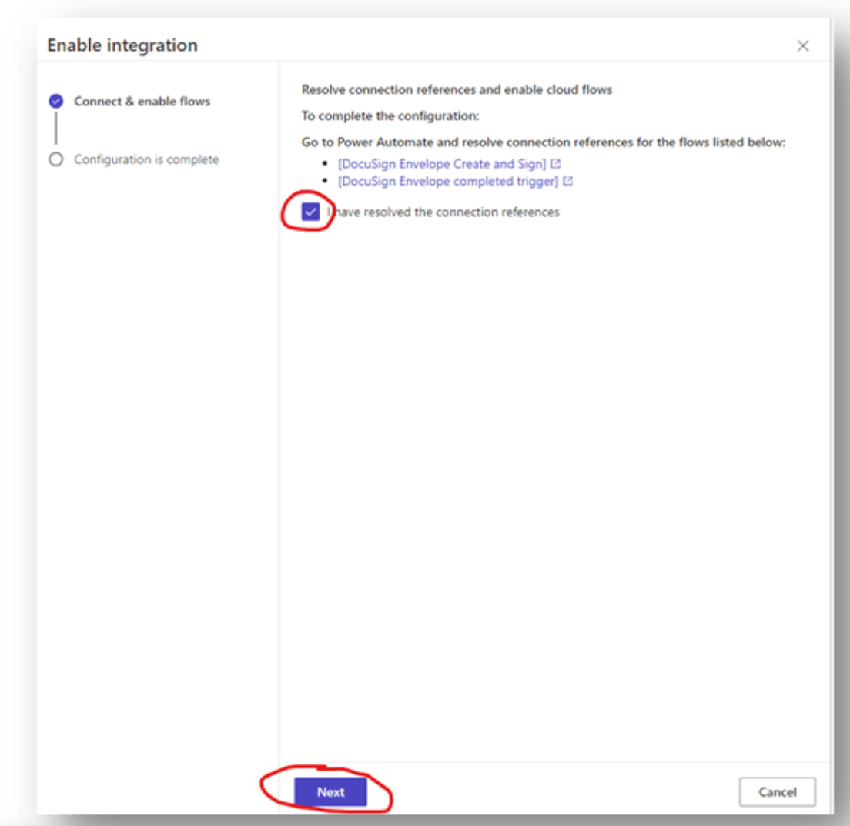

Under Integrations section 'Enable' the Docusign application
- Click on Enable to add the templates created in docusign site.
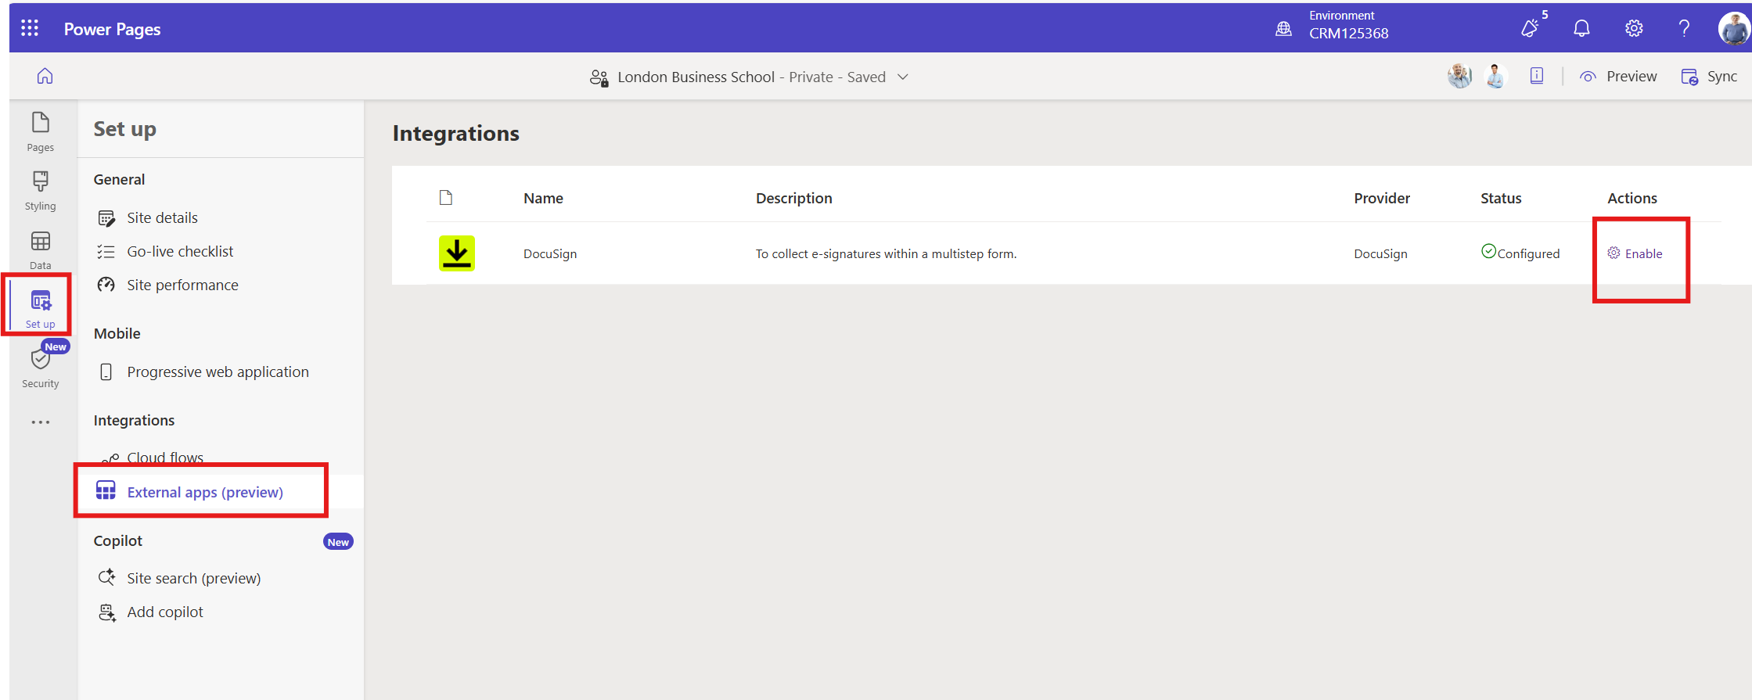
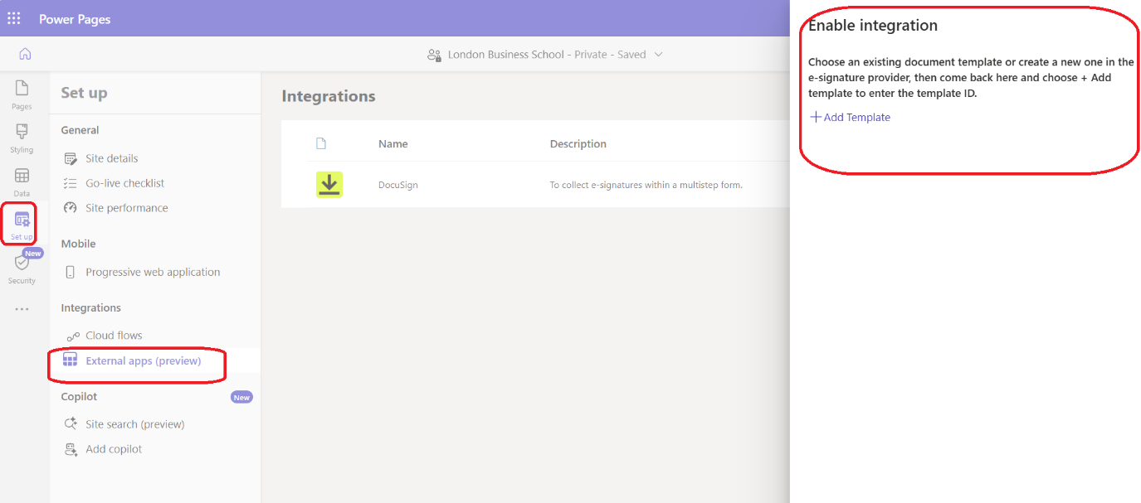

Click on 'Add Template'
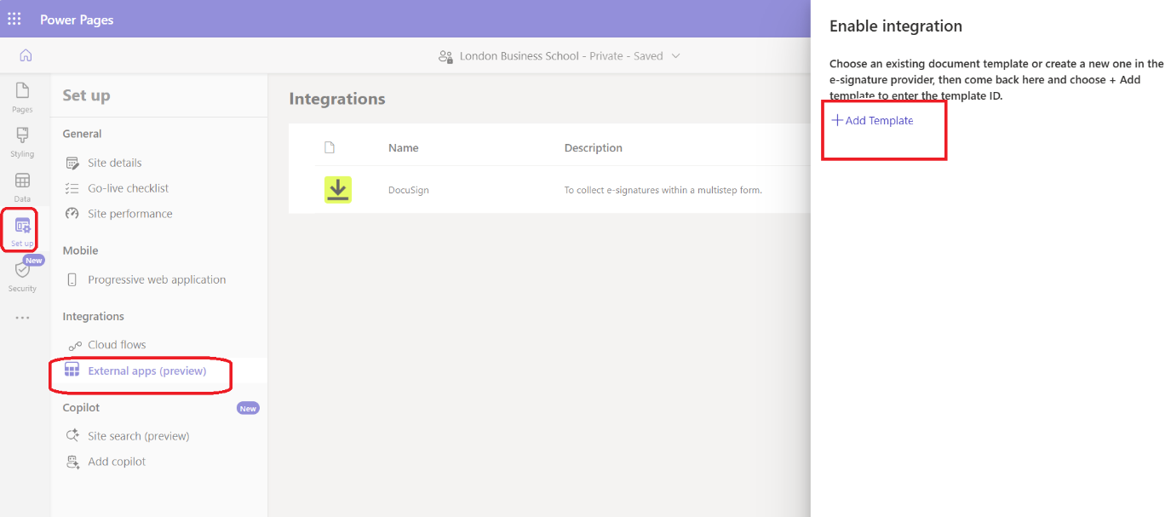

Populate the following fields grabbed from DocuSign and Save.
- Template ID
- Template Name
- Role Name
- Table
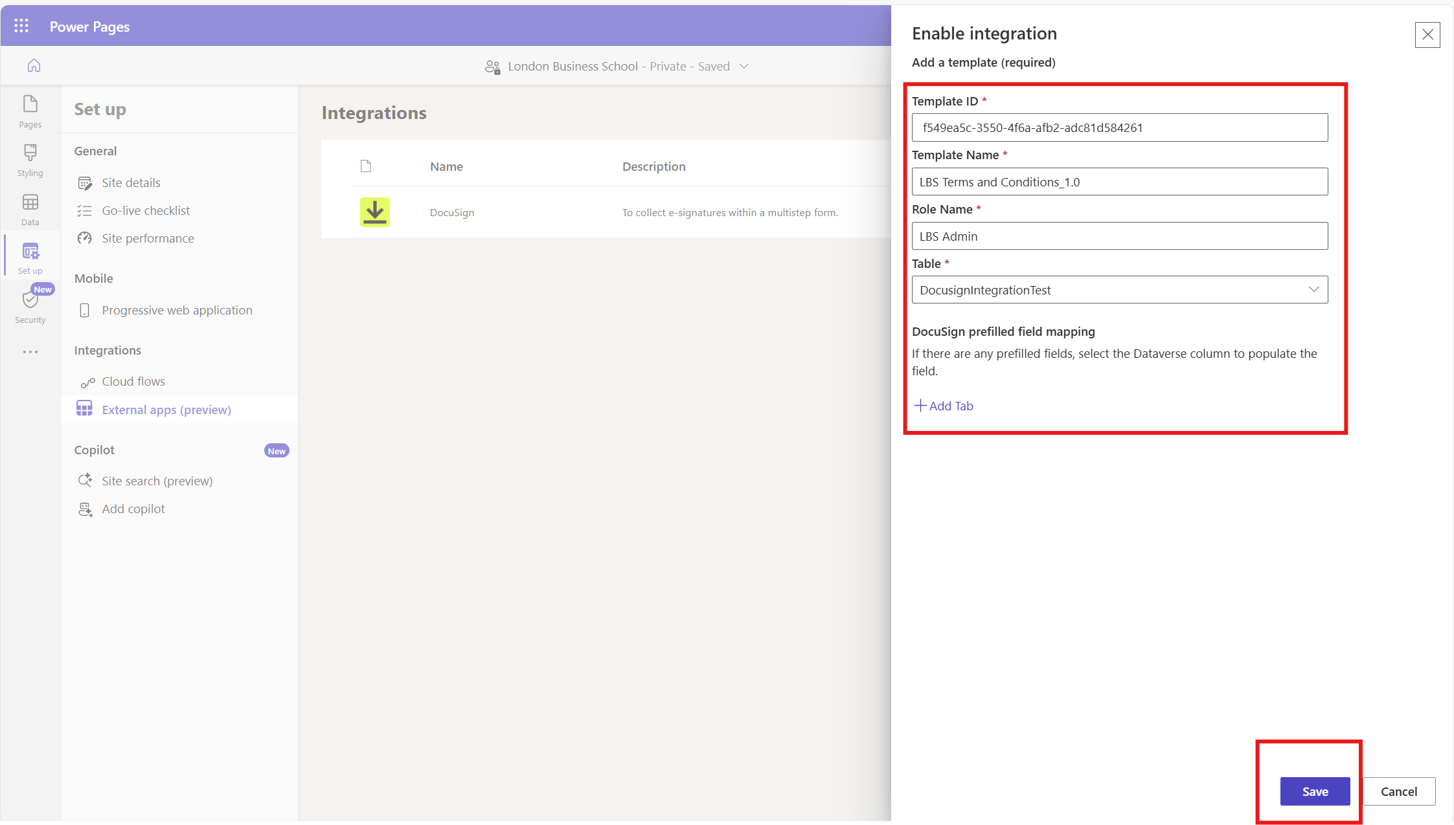

- Multiple templates created.
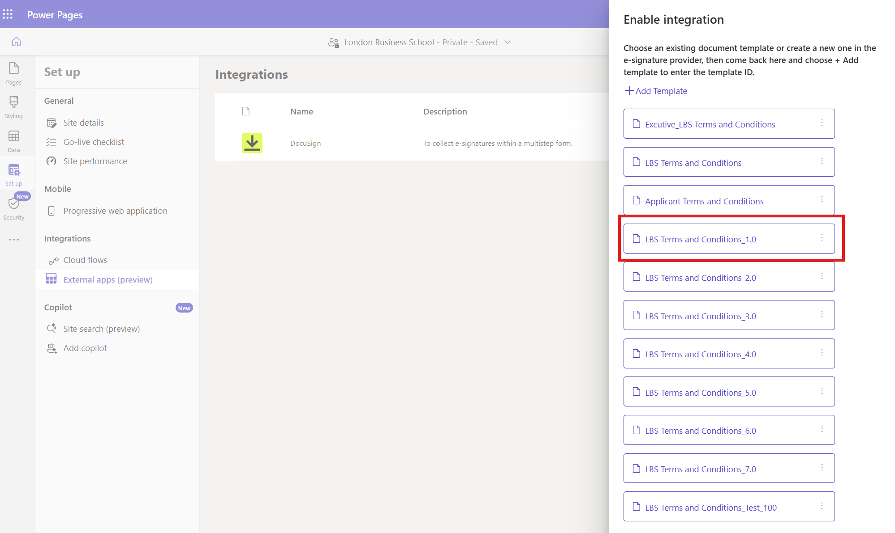

Add the cloud flow to the Power pages site( Most important flow which will run and get the documents from docusign)

Under Setup section in Design Studio, Navigate to Integrations > Cloud Flows
- Flow Docusign envelop create and sign is under the other flows so needs to be added to the cloudflows for this site so that this flow can be triggered.click on add to site button
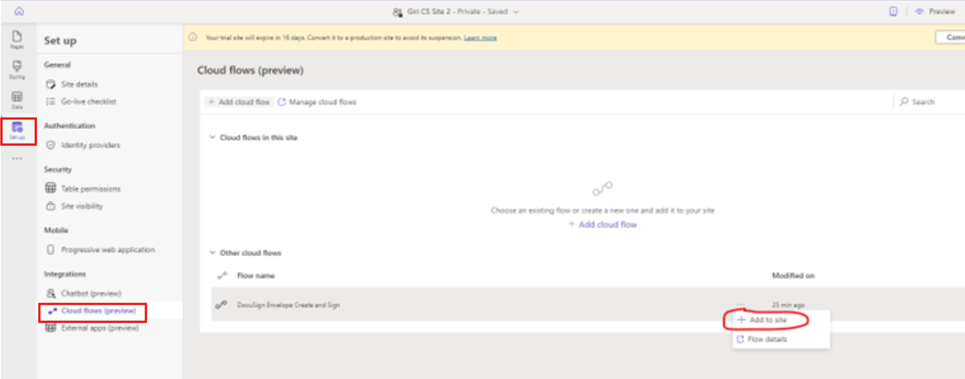

Select the 'DocuSign Envelope Create and Sign' flow and add to site
- Select the flow from dropdown list and add the role for the flow as Authenticated Users.

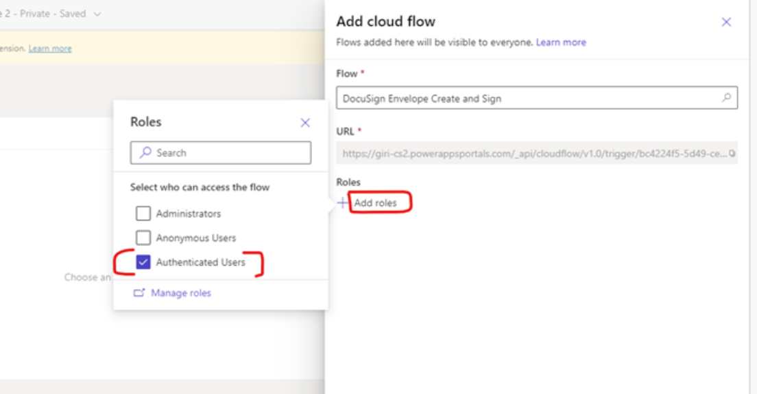

Flow “Docusign envelop create and sign”added to the power pages site
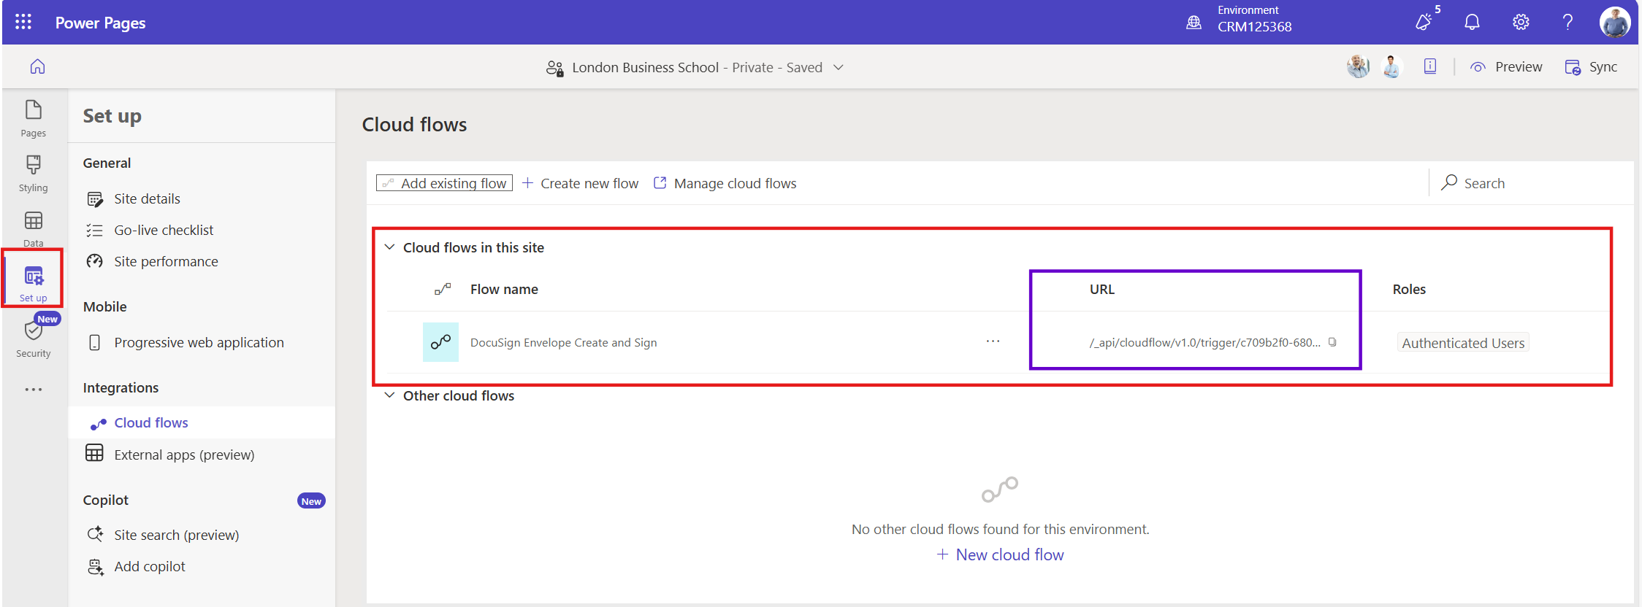

Note: Error got while testing so just mention this Note so that you can verify this step while testing the docusign integration.

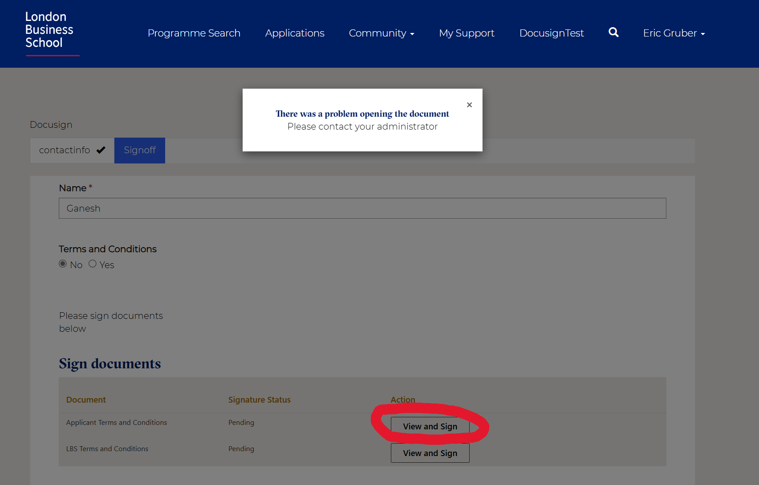

- Docusign envelop and sign Flow URL as heighted in screenshot should be same as URL in the Docusign output table action column. Refer the screenshot below.
If Both URLs are not same in that case flow can’t run and you will get error when you click on the grid button view and sign .

- Docusign output table action URL

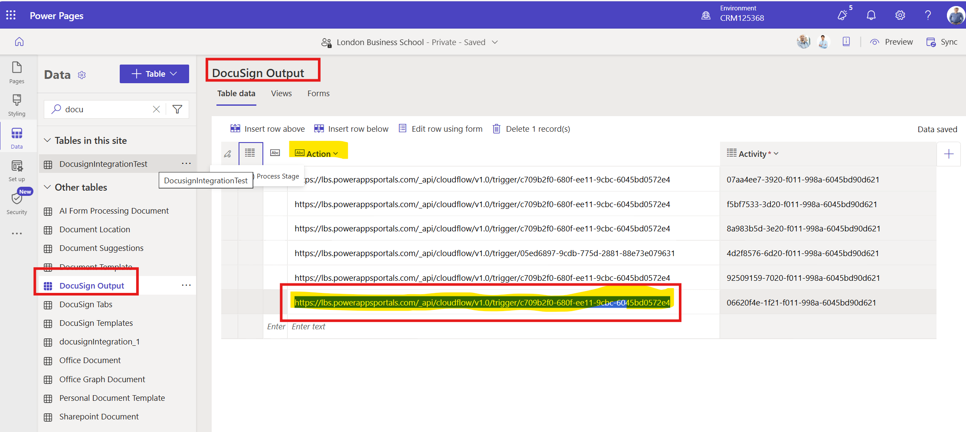
- FLOW URL
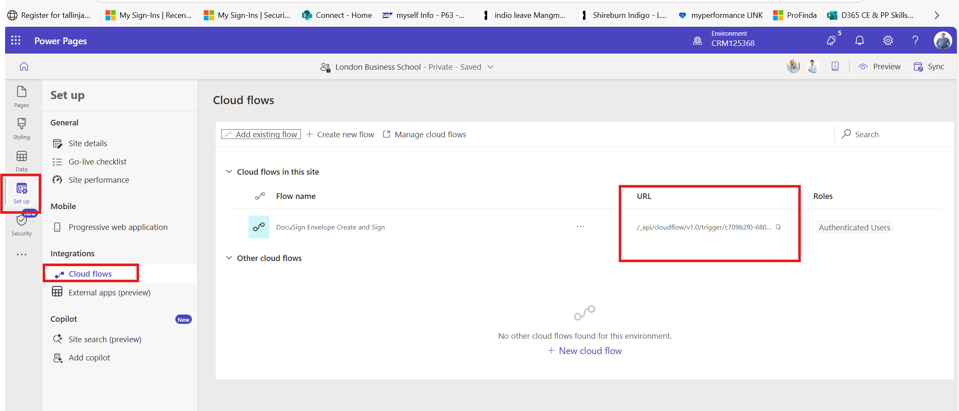

Add the Docusign Grid( PCF control ) to power page to show the documents to Sign

Navigate to Design Studio and edit the Form where you want to integrate the docusign grid (Step Settings)
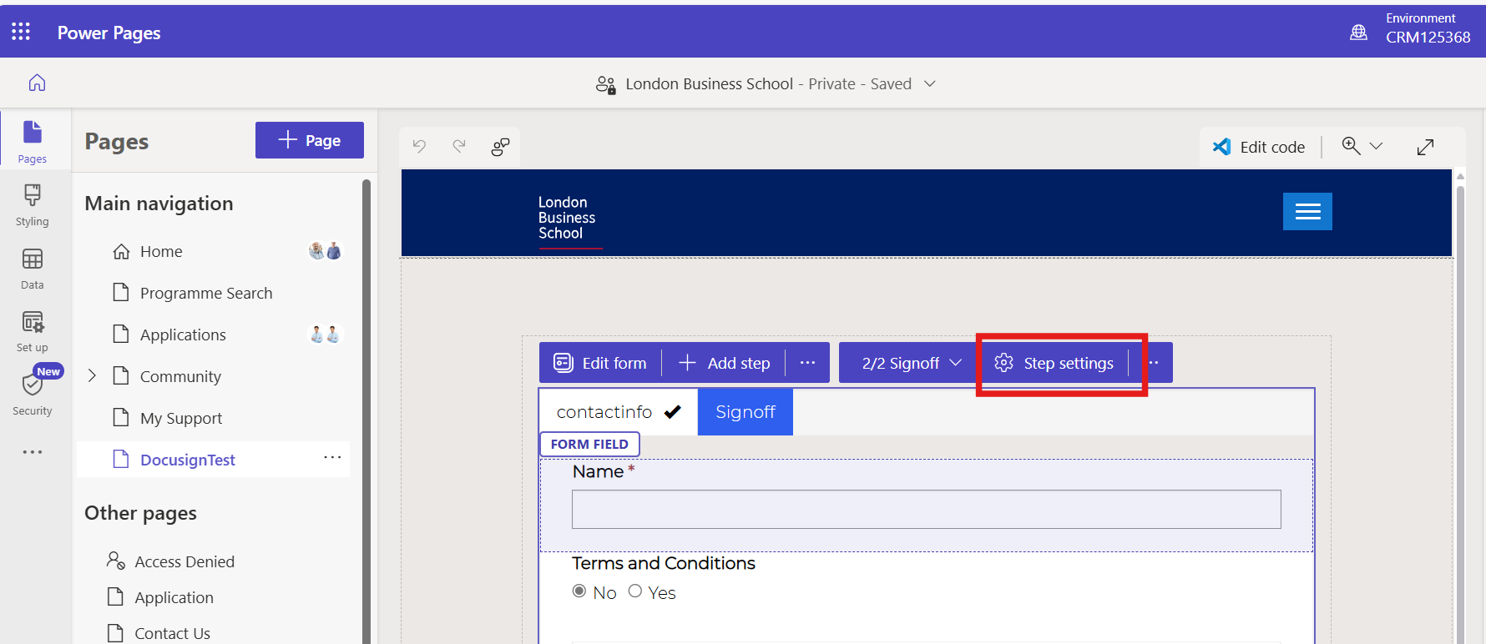

For one of the steps in Form > Steps Settings > Integrations > Select DocuSign template
- Enable the e-signature
- Select the template
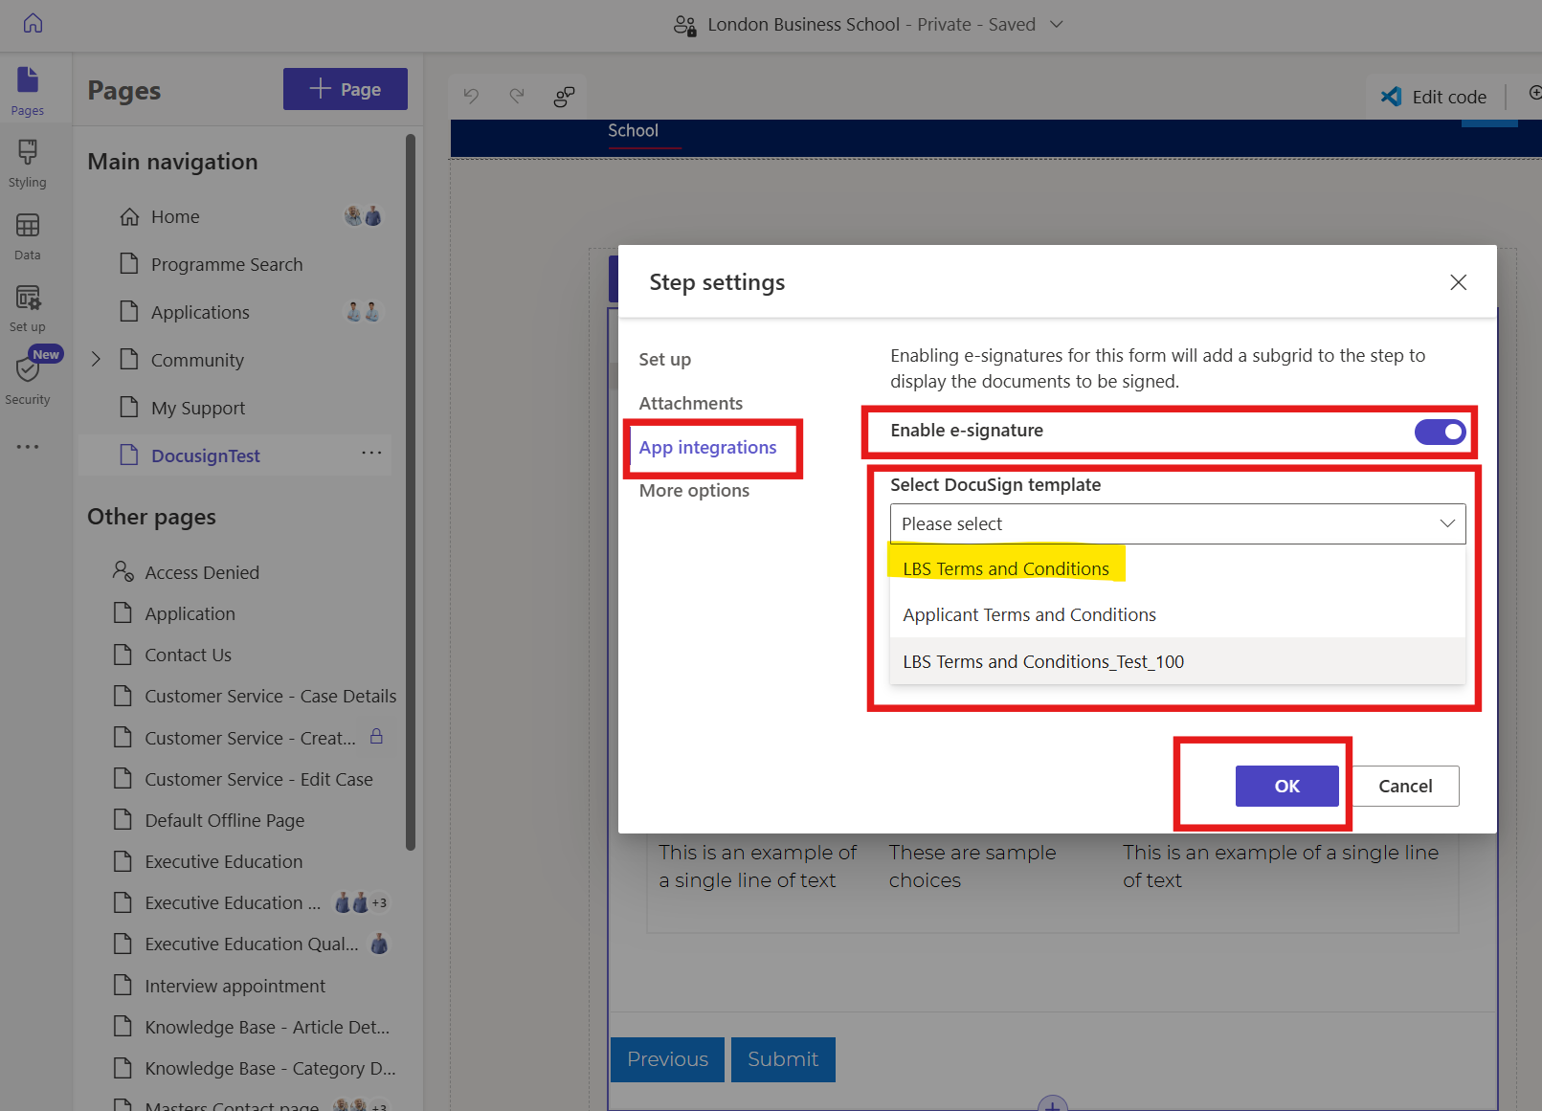

Docusign Grid added to form
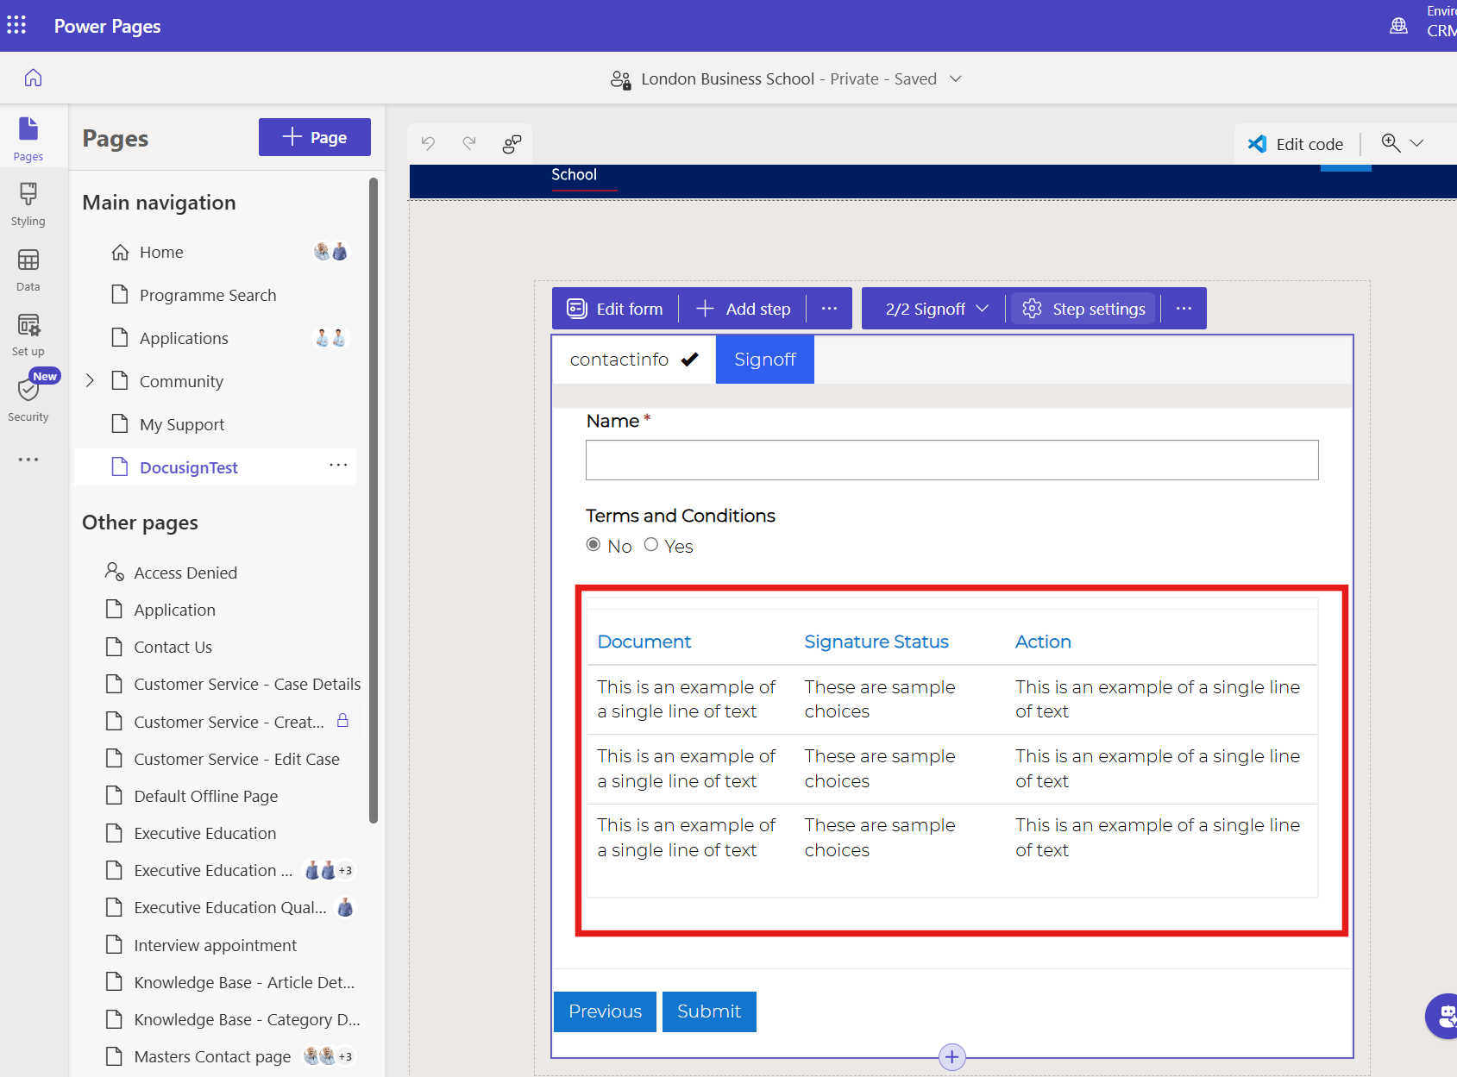

Sync the Power Pages Site
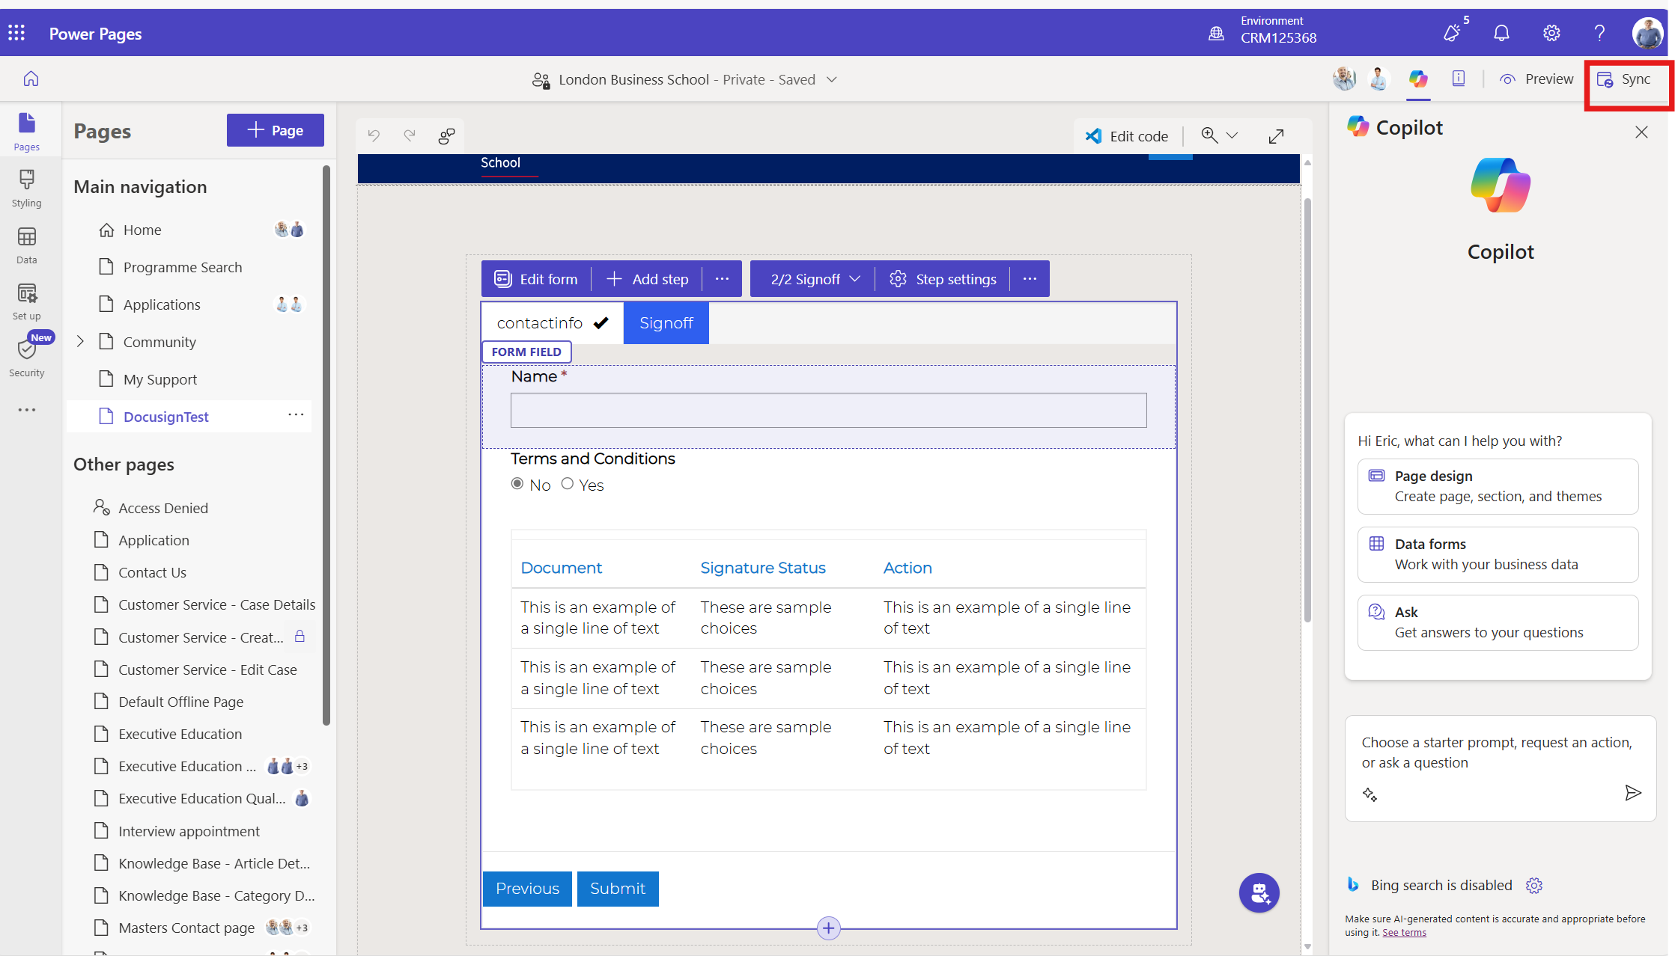

Test the complete integration

open the portal page and click on the View and sign button.
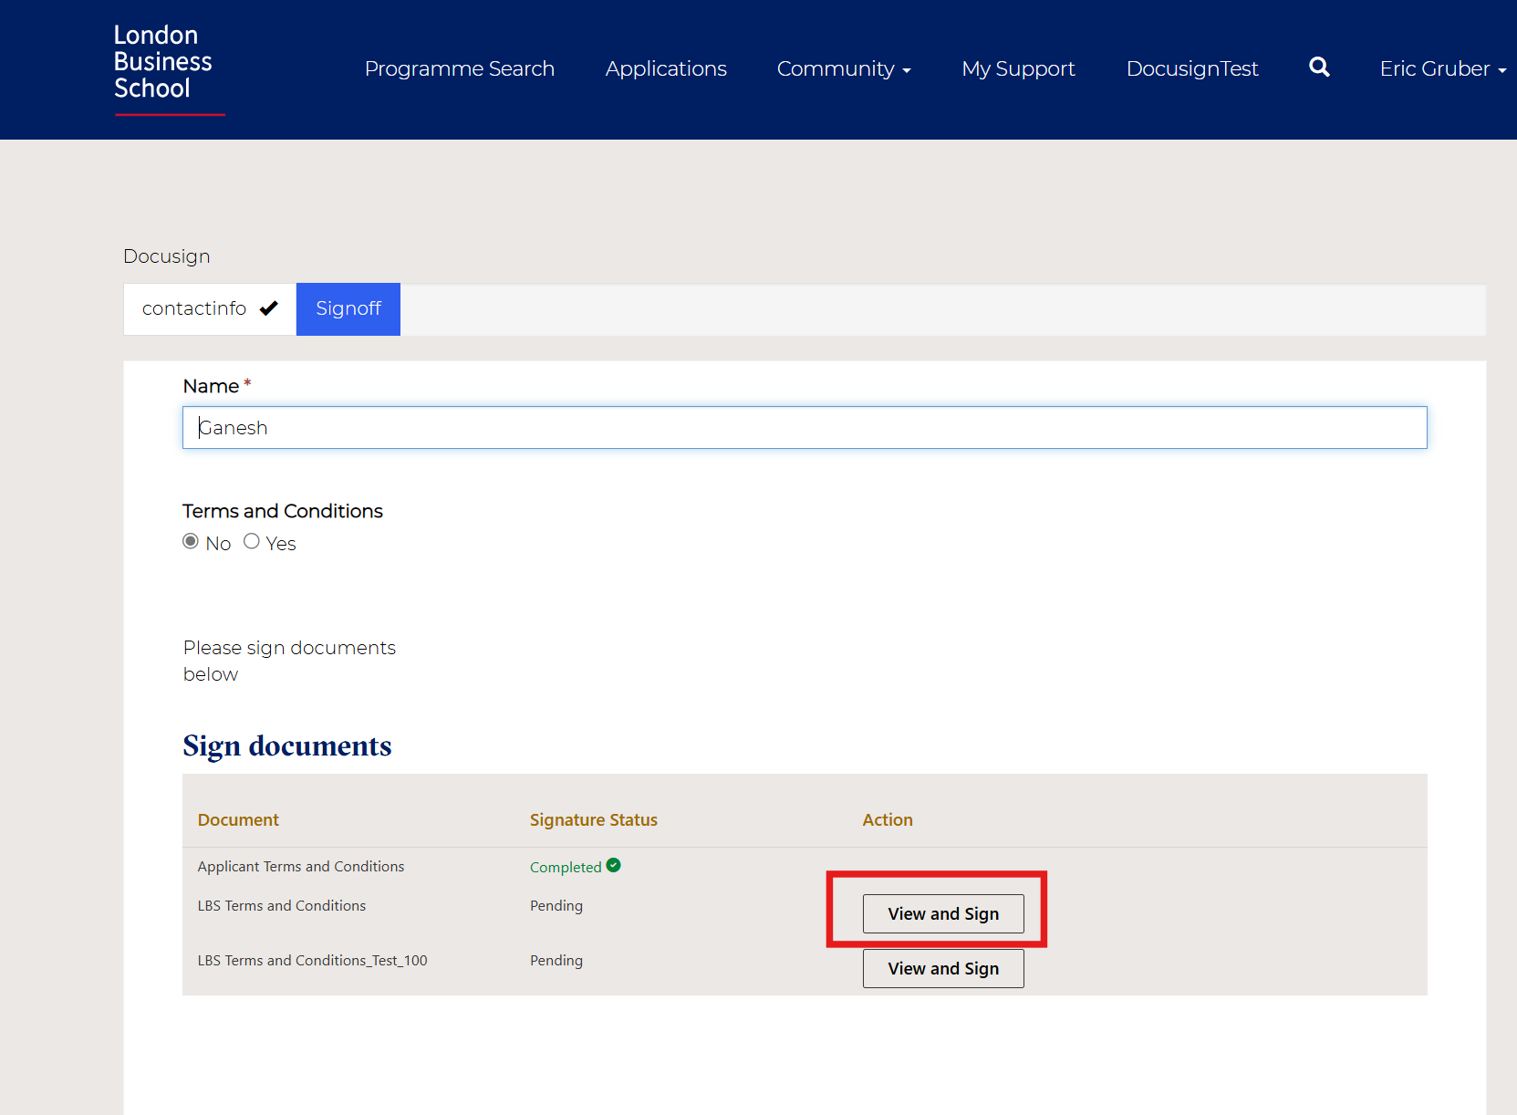

- Click on the view and sign button in grid : Then new docusign window will open with the document to sign:

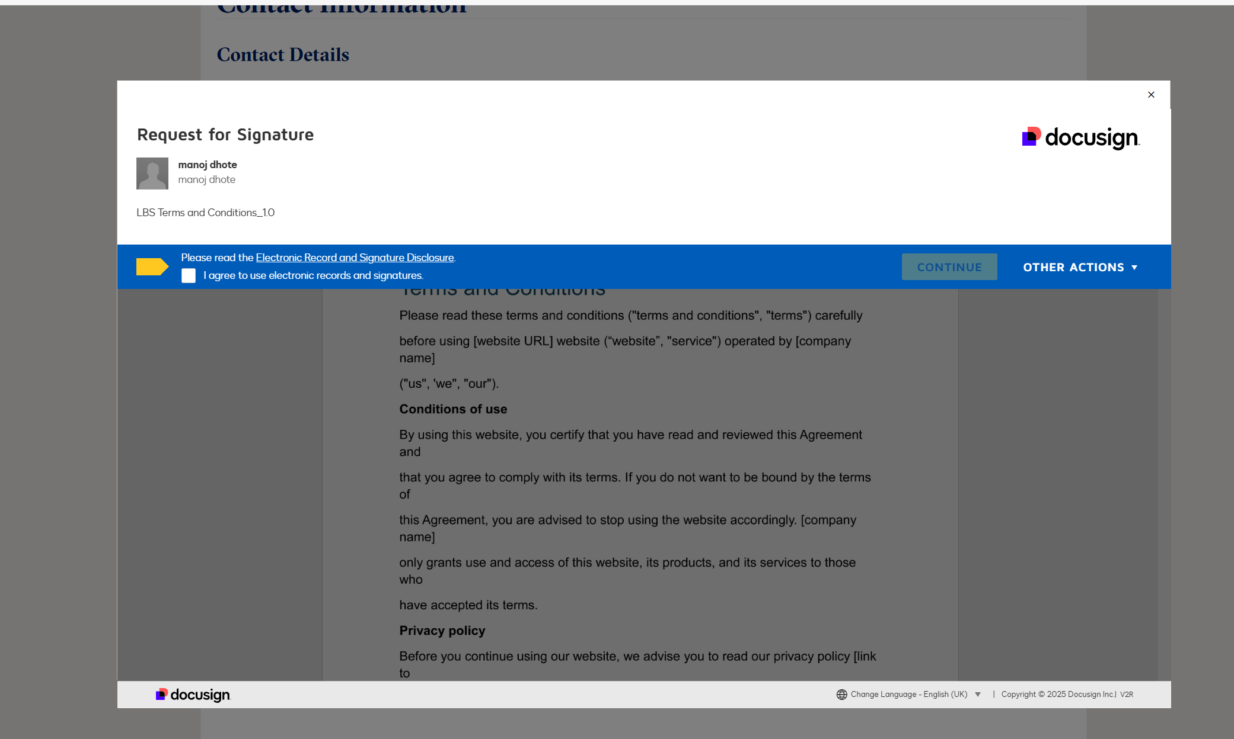

- Click on the terms and condition and continue:

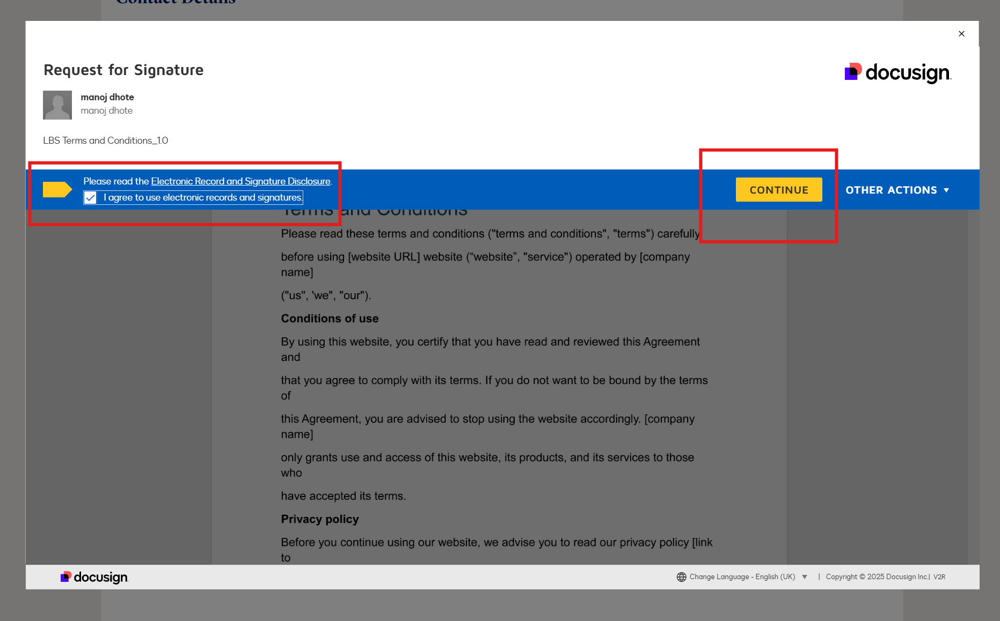

- Sign the doc and click on finish button.

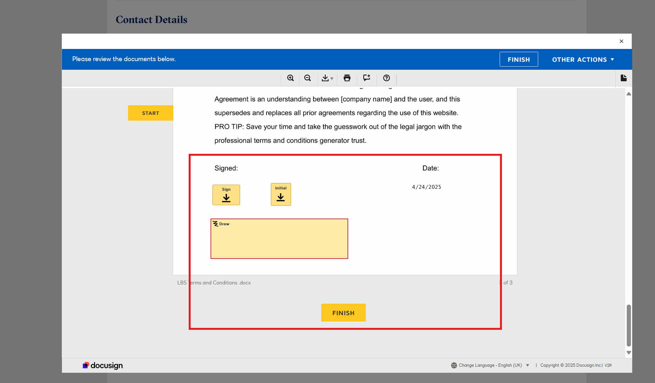

Login to the docusign site and verify the status of signed doc
- Go to the agreements
- Select the template/doc which is signed.
- Status of document will be sown as Completed.

